*****#******#******2-DfGIT 203 *Breck H. Camp CmI POBox47070 Atlanta GA 30362-0070*

Ml,II Ilnll.,,.1, III,.. II., .1... Hl.nl. ..HI Ml

**Experts Dr. Simon Liu  
and Mark Siluerman**

3 Offi(^Publication of ALOA—An International Association of Security Professionals

[www.aloa.org](http://www.aloa.org)

**PLUS!**

Biometric Resources

Greg Perry gains entry to a Mosler Class 5  
Black Label Uault Door

In-Depth couerage of the “999” or Bump Key  
Reuiew, Editorials, and More!

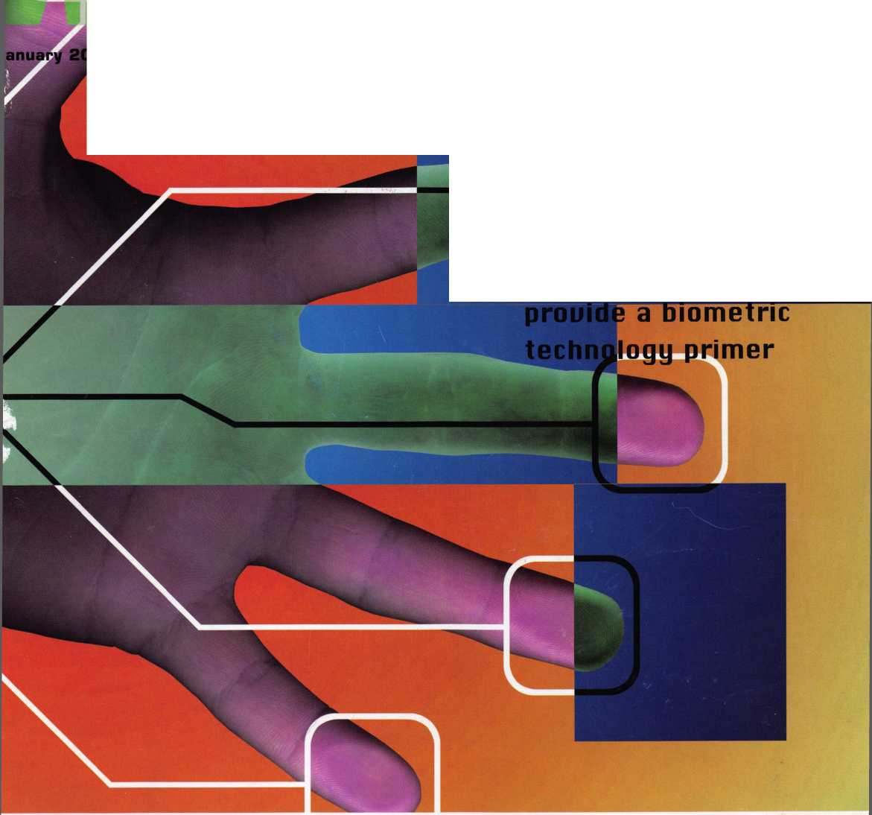

OUR STAND

WE’RE IN BUSINESS TO HELP YOU

**REDUCE DOWNTIME.**

Commercial vehicle insurance designed to help you get back on the road.

When your vehicle is out of business, so are commercial vehicle insurance as well as other you. That's why Allstate provides fast and fair insurance products designed to help keep your

claim service. Your local Allstate agent offers business in the race. Are you in Good Hands®?

Subject to availability and qualifications. Allstate Insurance Company and Allstate Indemnity Company, Northbrook, IL. Allstate County Mutual Insurance Company, Irving, TX. Allstate New .Jersey Insurance Company, Bridgewater, NJ.The "Gupped Hands" logo is a registered service mark and "Our Stand" is a service mark of Allstate Insurance Company. © 2005 Allstate Insurance Company, Northbrook, IL.

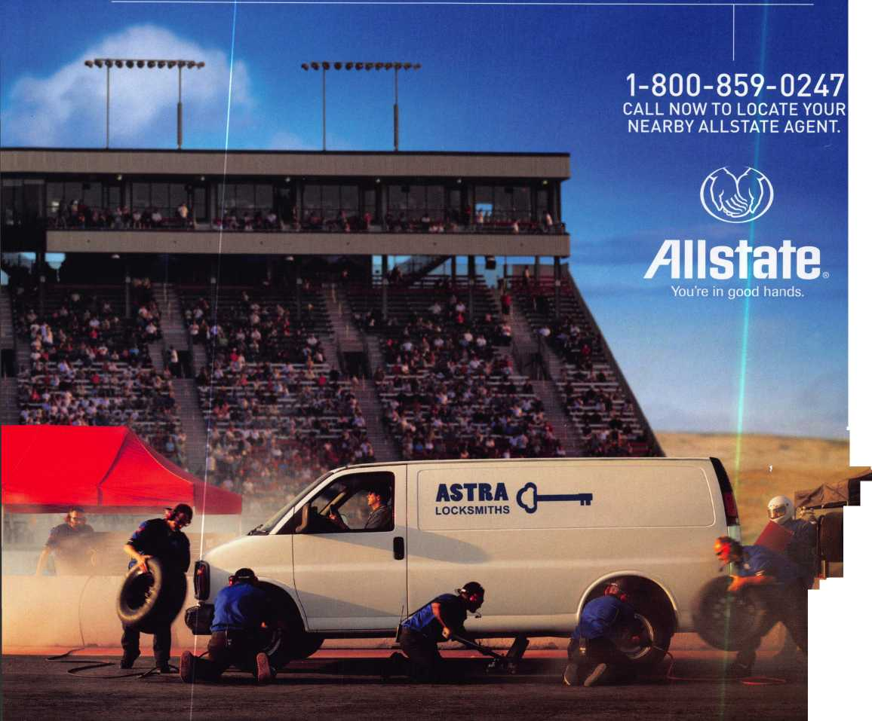

The Safe and Vault Technicians ^ssociacaion  
donnencion and Trade j^hom

March G—f2, 200S

*Hyatt Regency, Lexington KY*

*Safetech Oieite beautiful Lexington, Kentuckgl*

1>

JLL r^ey Mac, keeping up with the latest the industry has to offer has never  
been more important for us safe technicians. Let me tell ya, you gotta stay  
aware of what today's top safe distributors and manufacturers are putting out  
there. It's crucial to making a humdinger of a purchasing decision, buddy.  
And another thing, time is of the essence when it comes to education. New  
things pop up every day, Daddy-O, and that makes top-notch safe classes  
as good as gold. The only chance to get world-class education and meet  
with the industry's top distributors and manufacturers is the SAFETECH  
Convention and Trade Show. Boy, is it swell! SAFETECH 2005 offers you  
a chance to meet with potential customers and bolster business in ways  
you never thought possible. Discover the safes of tomorrow! Gee whiz,  
jump and jive your way into Safetech 2005, and you'll be part of our  
knock 'em, sock 'em show of all shows!!

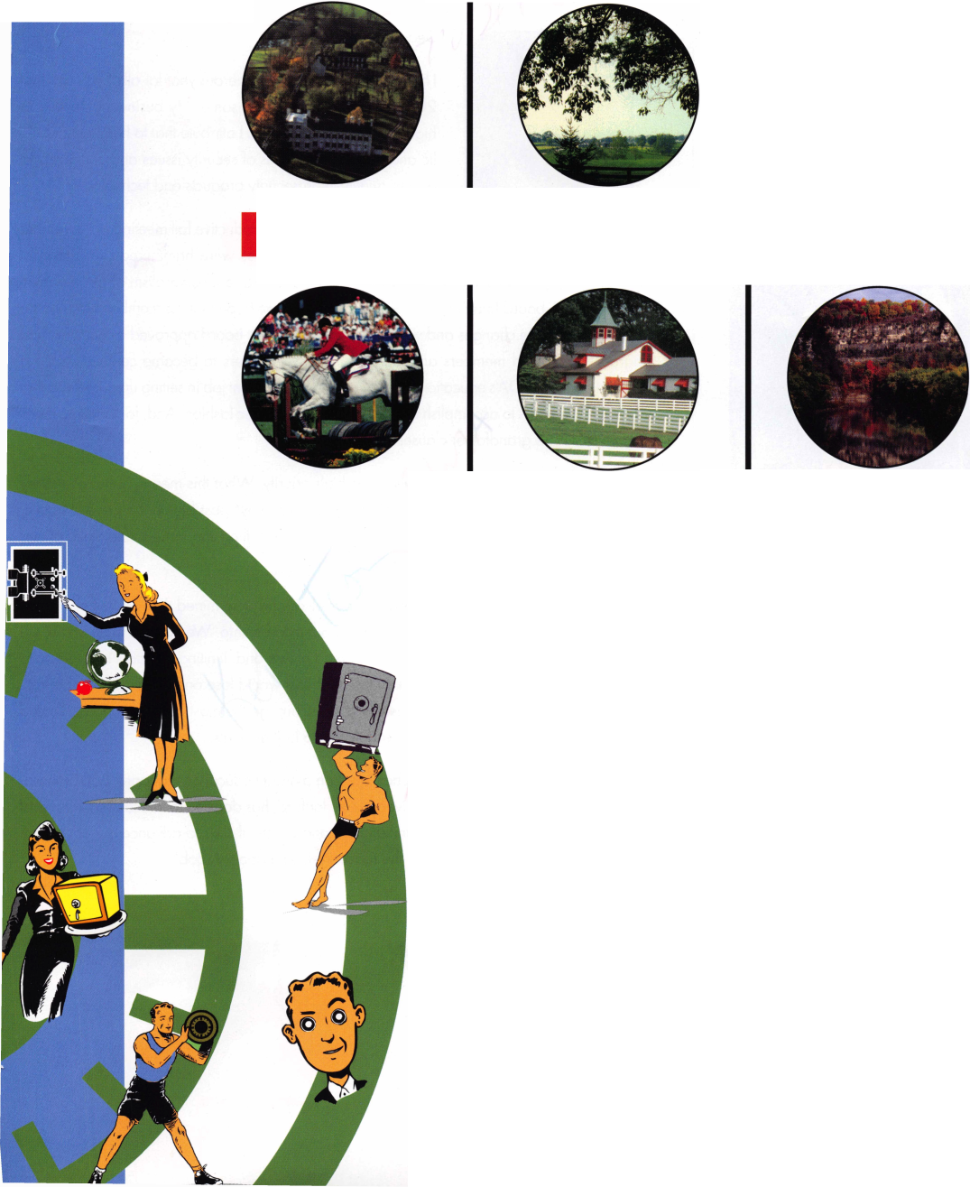

presidential

viewpoint

Important

Notice

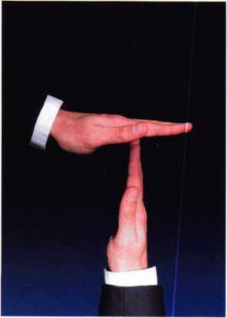

The Headquarters of the Associated Locksmiths of America will be relo­cating to a new office building some time early next year. During the time of the move, some ALOA services will be temporarily unavailable. These services include, but ar not lim­ited to, the following:

* Incoming Calls
* Database Inquiries
* Staff Support for the Web and all other departments

It is suggested that all ALOA and SAVTA members make note of this change. (This ad will be ammended when the actual move dates are confirmed.)

The ALOA staff is looking forward to the new location and the opportunity to provide you with improved mem­ber services during the New Year.

Dear Members,

I hope that 2004 was a prosperous year for all of you and that  
2005 will bring more of the same. My business achieved its  
highest sales total ever and, I attribute that to heightened pub-  
lic and private awareness of security issues and our ability to  
deliver quality, high security products and technologies.

Your ALOA board had a productive fall meeting in November  
and several important issues were hammered out. The most

important issue, in my opinion, deals with raising the level of professionalism of our member-  
ship. The ALOA board laid the groundwork for this and we hope that the membership sees the  
advantages of these changes and votes them into effect. The board approved a recertification  
program for certified members and will require new members to become certified within a  
specified period. ALOAs education department did an excellent job in setting up guidelines that  
will enable members to accomplish this in a simple and realistic fashion. And, for longtime mem-  
bers, there will be grandfather clauses.

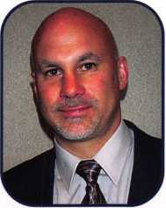

The board also set member recognition as a high priority. What this means is that as money  
is available, ALOA will promote its members in as many ways possible, to the general public.  
We will be getting the ALOA symbol out there and extolling the virtues and skills of our  
certified locksmiths.

The ALOA board also did an evaluation on ourselves and determined that we will govern as  
efficiently as possible and still adequately serve our membership. We have voted to shrink the  
board by having one international director instead of two and, limiting directors in a region to  
no more than two. That would mean that the northeast would lose one director. We also insti-  
tuted a program that would help us identify and encourage the most qualified and dedicated  
individuals to serve on the board and lead ALOA to higher levels.

I am pleased to announce that ALOA has hired an assistant education manager. Bob Stafford,  
CML, former head locksmith at the University Of Hartford, has decided to relocate to Dallas and  
allow us to use his educational, organizational, and practical skills to advance our education-  
al programs, both "in-house" and on the road. Welcome aboard, Bob!



President

Keynotes • January 2005



SWEET

Get Ready for BLOR 2005,

a powerful resource to explore innouation and  
form industry alliances. This year we’ue thought of  
euerything from an exciting location, comfort-  
able accommodations and a conuention center  
that is equipped to handle your euery need.

Located just minutes from douintouin  
Chicago, Rosemont, Illinois is the  
perfect “business uillage”, designed specifically  
to make your stay conuenient, comfortable  
and aboue all, successful!

The 49th Rnnual RLOR Conuention and Security Expo  
offers top-notch classes, workshops, networking  
opportunities and cutting-edge technology.

Rnd don’t miss out on the fine dining and enter-  
tainment options that Chicago has to offer. Shop  
at the world-famous Magnificent Mile. Eat at  
Morton’s of Chicago or Harry Caray’s Italian  
Restaurant, llisit the Nauy Pier or catch a ball  
game. The options are endless when you register  
today for the single-most important euentin  
the locksmithing industry.

Baby, you knoiu you luant to yo!

**RLOH 2005**

Sweet Home Chicago

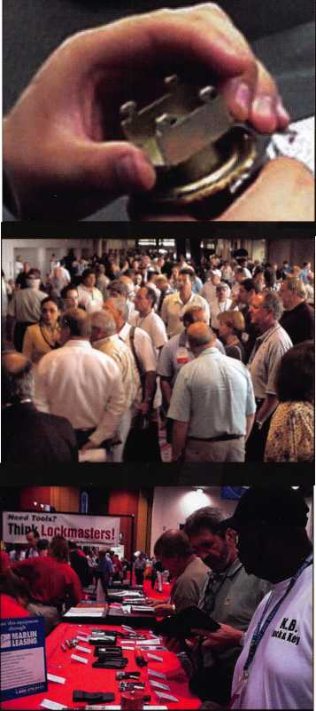

features

BIOMETRICS 2005

**10**

A Practical Guide to Biometrics Technology

As organizations search for more secure authentication methods for user access, e-commerce, and other security applications, biometrics is gaining increasing attention. But should your company use biometrics? And, if so, which ones should you use and how do you choose them? There is no one best biometric technology. Different applications require different biometrics.

by Simon Liu, PhD and Mark Silverman

**14**



Biometrics Resouorces

A helpful guide to companies and resources for Biometrics products and services.

Go Your Own Way

This month well look at a Mosler Class 5 Black Label Vault door. The job was simple enough. The instructions were to open the vault door because the combination was lost. On a GSA door, if the label is to be maintained, holes must be placed under the dial ring. In addition, a hole must be repaired properly. How would you drill it?

by Greg Perry, CML, CPS

**22**

**26**

Opening Locks with the **"999"** or Bump Key

This article will examine a technique that allows a conven­tional pin tumbler, dimple, or axial pin tumbler lock to be opened in seconds with little skill and no apparent dam­age. The procedure poses a real threat to the security of many pin tumbler mechanisms but can also provide the locksmith and rapid entry team with a quick method to open a cylinder. It is important for security professionals to understand the process and the means to defeat it.

by Marc Weber Tobias

Review: LSS+

LSS+ is not only the best reference in this industry, but also extremely invaluable in other areas. In the class, Defense Against Methods of Entry (DAME), the major learning objective is to be able to identify the weak points in any locking device (including unfamiliar locks) and to deter­mine the most likely and best methods of attack. This makes for professional entry and helps a techinician deter­mine how to best defend against these methods of entry.

by Harry Sher, CL, CPS

**Departments**

**34**

Editorial: Tubular Locks and the Kensington/Kryptonite Fiascos

In August, there were two alerts on [www.security.org](http://www.security.org) regarding the insecurity of the tubular locks utilized by Kensington and other computer cable lock manufacturers. As a result, over 100,000 hits to the website were received in the following days from corporations, govern­ments, schools and private individuals throughout the world, wondering why their locks could be easily and quickly bypassed with a ball point pen. A public relations nightmare followed, as well as significant costs to repair the damage and replace the locks, by Marc Weber Tobias

|  |  |
| --- | --- |
| **r** |  |
| **AD INDEX** | |
| **Allstate** | **Inside Front Cover** |
| **Kaba Access Control** | **7** |
| **Professional** |  |
| **Business Products** | **15** |
| **Keedex** | **20** |
| **T-Core** | **21** |
| **NEW! Buyer's Marketplace 42** | |
| **CCL** | **Inside Back Cover** |
| **Hickok** | **Back Cover** |
| **L** | **J** |

v

;ir

|  |  |  |  |  |  |  |  |  |
| --- | --- | --- | --- | --- | --- | --- | --- | --- |
| Presidential |  | Executive | 5 | Calendar | 8 | Classified | 36 | Legislative 40 |
| Viewpoint | 2 | Applican | 6 | Core | 9 | Associate Members | 38 |
|  |

Visit our website at

[www.aloa.org](http://www.aloa.org)

executive

Volume 51, Issue 1

Additional contact information for the ALOA Board and most Keynotes authors is  
available through "Locksmith Search'" on the ALOA Web site- [www.aloa.org](http://www.aloa.org) or by  
contacting the ALOA office at 3003 Live Oak Street; Dallas, TX 75204; (800)532-2562;  
FAX (214)827-1810; e-mail [aloa@aloa.org](mailto:aloa@aloa.org).

Publications Manager

Betty Henderson [betty@aloa.org](mailto:betty@aloa.org)

Technical Editor

David Lowell, CML, CMST [david@aloa.org](mailto:david@aloa.org)

Editorial Advisor

John Cannon, CML [jcannonl@cox.net](mailto:jcannonl@cox.net)

Advertising Sales

Kim Hammond voice: 817-645-6778

Fax: 817-645-7599  
e-mail: [adsales@aloa.org](mailto:adsales@aloa.org)

Executive Director

Charles W. Gibson, Jr., CAE [charlie@aloa.org](mailto:charlie@aloa.org)

Associate Executive Director

David Lowell, CML, CMST [david@aloa.org](mailto:david@aloa.org)

Convention & Meetings Manager

Jo Anne Mims [joanne@aloa.org](mailto:joanne@aloa.org)

Operations/Membership Manager

Mary May [mary@aloa.org](mailto:mary@aloa.org)

Contributors

Jerome Andrews, CML Ray D'Adamo, CML

Paul Chandler, CRL Billy Edwards, CML

Claire Cohen, CML Dan Graffeo, CRL,CMST

Brian Costley, CML, CMST Jim Hancock, CPL

Eric Costley, CRL Jeff Nunberg, CML, CMST

Mission Statement: The Associated Locksmiths of America, Inc. is dedicated to enhancing the professionalism, education and ethics among locksmiths and those in related sectors of the physical security industry. With approximately 10,000 members in the United States, Canada and the freeworld, ALOA is poised to help members obtain the knowledge, the strength, and the confidence to perform their role in the physical security field with pride and dignity. But it is only through active involvement and participation that ALOA can fully achieve its potential—and can help members to achieve theirs.

Policies: Keynotes® is the official publication of the Associated Locksmiths of America, Inc. (ALOA). Keynotes® acts as a moderator without approving, disapproving, or guaranteeing the validity or accuracy of any data, claim, or opinion appearing under a byline or obtained or quoted from an acknowl­edged source. The opinions expressed by the authors do not necessarily reflect the official views of ALOA. Also, appearance of advertisements and new products or service information does not constitute an endorsement of products or services featured by the Association. The Association does not accept responsibility for the inaccuracy of any data, claim, or opinion appearing in this publication, due to typographical errors on the part of the authors, Association staff or its agents.

Editor's Note: This publication is designed to provide accurate and authoritative information in regard to the subject matter covered. It is provided and disseminated with the understanding that the publisher is not engaged in rendering legal or other professional services. If legal advice and other expert assistance is required, the services of a competent professional should be sought.

Authors' Payment: Payment for eligible submissions to Keynotes will be based on the following criteria: topic, time spent and past contributions. Authors who regularly submit to Keynotes® are generally paid a higher rate. The latter is especially true of authors who write to fit specific editorial needs and submit said copy by Keynotes® deadlines. As a general guideline: Average payment for a 750 word, business or 'light' technical article would be $200. Payment for a 1500 word article involving significantly higher time and research efforts would be $400.

Payment will not be offered for articles submitted by ALOA employees or members of the ALOA Board of Directors (unless material is of a technical nature), nor for articles submitted by a company that promote that company's products or services. ALOA reserves the right hot to pay for articles sub­mitted by an individual(s) that promote a particular company's products or services.

Disclaimer: The Associated Locksmiths of America, Inc., (ALOA), reserves the right to refuse any article for any reason. Additionally, ALOA reserves the right to edit, amend or modify any article submitted for publication in order to preserve technical accuracy, clarity, fairness or grammatical cor­rectness. ALOA will make the best efforts to notify the author of any changes. The extent of ALOA's liability for any article or information contained therein will be a notice of correction or retraction in the next possible issue.

Government Relations Manager

Paul Kanitra [paul@aloa.org](mailto:paul@aloa.org)

IT Operations Manager

Greg Jackson [greg@aloa.org](mailto:greg@aloa.org)

Comptroller Kathy J. Romo

Membership Coordinator Shelly Jett

Convention & Meetings Assistant Karen Lyons PRP/Education Coordinator Hope Rodriguez

Accounting Coordinator

Mail Room Coordinator Kevin Wesley

Publications Coordinator Bryan Dease

Executive Assistant Sue Langford

Receptionist Wendy Wilder

Randy Simpson, CML, CPP Tom Seroogy Robert Stafford, CML Charles Stephenson, CPS

Dave Thielen, CML Dennis Watanabe, CML, CMST

Greg Perry, CML,CPS



President

William L. Young, CML  
(610)647-5042  
presidenf@aioa .org

Secretary

John Sodertand, CML, CMST  
(414) 327-5625  
[secretary@aloa.org](mailto:secretary@aloa.org)

Directors, Northeast

Robert E. Mock

(856) 863-0710  
ned i rector@aloa. org

Peter Sarailian, CRL  
(973)890-9797  
[nedirector@aloa.org](mailto:nedirector@aloa.org)

Vernon Kelley, CPL  
(609) 771-3126  
[nedirector@aloa.org](mailto:nedirector@aloa.org)

Directors, Southeast

Tom Gillingham Jr., CML, CPS

(615)2640747  
sed irector@aloa. org

Ken Kupferman, CPL  
(813)961-5784

[sedirector@aba.org](mailto:sedirector@aba.org)

Director, North Central

Mark E. Blum, CML, CPS  
(517) 482-5809  
[ncdirector@aloa.org](mailto:ncdirector@aloa.org)

Director, South Central

CD Lipscomb, CML, CPS  
(903)874-3522  
[scdirector@aloa.org](mailto:scdirector@aloa.org)

Directors, Southwest

Gordon R. Racine, CML  
(719) 384-4707  
swdirector@aloa .org

Julie McCluney, CRL  
(714) 636-5652  
[swdirector@aloa.org](mailto:swdirector@aloa.org)

Director, Northwest

Jim Jeffries, CPS  
(208)743-1 101  
[nwdirector@aloa.org](mailto:nwdirector@aloa.org)

Director, European

Hans Mejlshede, CML

(453)539-3939

[eurdirector@aloa.org](mailto:eurdirector@aloa.org)

Director, Asian

JoeJ. Lee, CRL  
(215)289-2404  
[asiandirector@0loa.org](mailto:asiandirector@0loa.org)

Director, Associate

Paul M. Justen  
(800)333-6953  
asdirector@a!oa. org

Trustees

[trusfees@aloa.org](mailto:trusfees@aloa.org)

Randy Simpson, CML  
(281)240-5959

John J. Greenan, CML, CPS  
(773) 486.2030

Past Presidents

2001-2003 Randy Simpson, CML  
1999-2001 John Greenan, CML, CPS  
1997-1999 Dallas C. Brooks  
1995-1997 David Lowell, CML, CMST  
1993-1995 Breck Camp, CML  
1991-1993 Henry Printz, CML  
1989-1991 Evelyn Wersonick, CML, CPS  
1987-1989 Leonard Passarello, CPL  
1985-1987 Joe Jackman, CML  
1983-1985 Stanley Haney, CPL  
1981-1983 Louis LaGreco, CPL  
1979-1981 John Kerr, RL  
1977-1979 Clifford Cox, CML  
] 974-1977 Charles Hetherington  
1972-1974 Gene Laughridge  
1970-1972 William Dutcher, RL  
1968-1970 Constant Maffey, RL  
1966-1968 Harold Edelstein, RL  
1964-1966 William Meacham  
1962-1964 Robert Rackliffe, CPL  
1960-1962 Edwin Toepfer, RL  
1956-1960 Ernest Johannesen

Keynotes® (ISSN 0277 0792) is published monthly except for the combined June/July issue by The Associated Locksmiths of America, Inc.,  
3003 Live Oak St., Dallas, TX 75204-6186. Telephone: (214) 827-1701; FAX (214) 827-1810; e-mail [aloa@aloa.org](mailto:aloa@aloa.org). Subscription rates for  
members-$15.00 per year. Periodical class postage paid at Dallas, Texas. POSTMASTER: Send address changes to: Keynotes, 3003 Live Oak St.,  
Dallas, TX 75204-6186. © Copyright 2003, All rights reserved. No part of the contents may be reproduced or reprinted in any form without prior

written permission of the publisher.

Keynotes • January, 2005

CO

OH

Fort Collins

John Stoody

Sponsor: Raymond J. D'Adamo CML

Mansfield

Jerry L Beatty

Sponsor: Thomas K. Gatton

GA

Albany

Barry S. Golden

Sponsor: David H. Hall CRL

TX

Little River

Jimmy Sharp

Sponsor: Donald D. Bulls

IL

Oak Lawn

Blanca Castorena Carlos R. Lancerio

KS

Shawnee Mission

Matthew T. Conradt

Sponsor: Steven L. Conradt CRL

Ml

Kalamazoo

Larry K. Gillam

Sponsor: Lonnie G. McKinney PhD, CML

Madlena M. Ewert

Sponsor: Todd A. Phillips CRL

NH

Durham

Troy W. Hartson

Sponsor: William S. Jones

Pelham

Brian Emond

Sponsor: Steve Joyal

Canada

Regina Saskatchewan

Andy Tessier

Sponsor: Klaus Jakob

ON

Ottawa

Andre Cote'

Sponsor: R Paul McKay

England

Solihull, West Midi

Jason Rainey

Sponsor: Ken Dale

South Africa

Cape Town

Trevor Grade

Sponsor: Ian R. Grade

These applicants are scheduled for clearance as members of ALOA. The names are published for member review and comment within 30 days of this Keynotes issue date,  
respectively, to ensure applicants meet standards of ALOA s Code of Ethics. Protests, if any, should be addressed to the Membership Department and must be signed. Active  
Membership applicants (a) have worked in the industry two or more years. Allied Membership (AL) applicants are not locksmiths, but work in a security-related field.

Apprentice Membership (AP) applicants have worked in the industry less than two years.

Keynotes • January 2005

Knob

; I ■.

1000 Series

Kaba Access Control continues to offer you a simple, strong and secure pushbutton lock alternative, even in today’s high tech world. With over 40 years of proven performance, you can count on Simplex to handle all of your access control needs.

* Keyless convenience no keys or cards
* Easy to install no wiring or computers
* Easy to maintain no batteries to replace
* Easy to manage one code, can be changed in seconds

The Simplex 1000 Series family of heavy-duty locks is perfect for restricting access to private, security sensitive areas. Provides an economical alternative for any access point that does not require electronic features. Locks are easily installed on cylindrical ASA 161 or standard (86) mortise door preps. The all-metal, grade 1 design provides a virtually maintenance free access solution.

Simplex 1000 Series locks are available in a variety of options.

Lever

Mortise & Deadbolt

Passage & Lockout

WIN

**SIMPLEX**

**SHOPPING**

**SPREE**

Back to Back

Send us your 1000 Series Installation success story and you’ll be entered for a chance to win a FREE $500 Simplex Shopping Spree. Each entrant will also receive a FREE Simplex ball cap. The best story will be selected to appear on the Kaba website with your picture and story. Send your story and photo to Simplex Shopping Spree, 2941 Indiana Ave., Winston-Salem, NC 27105. (One story per dealer)

Exit Device

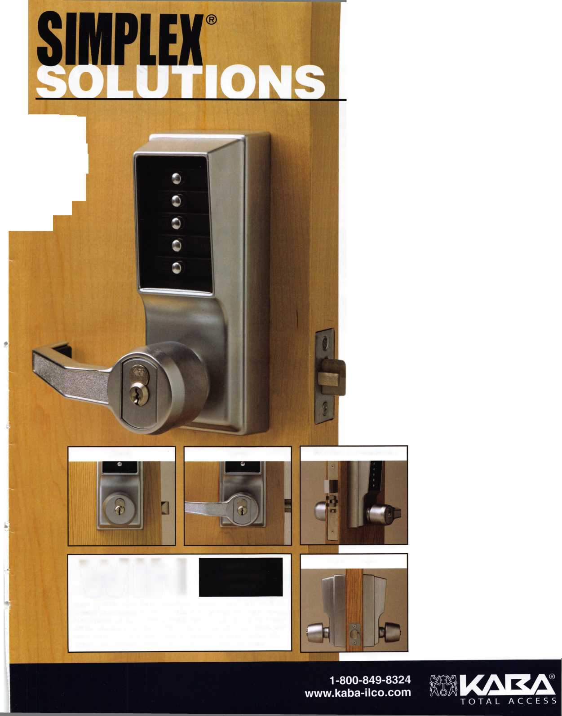

p c o m

events

u

i n g

|  |  |  |
| --- | --- | --- |
| **z**  < -* | 12 New York Master Locksmiths' Assoc. Monthly Meeting  NYC/Long Island Area  718 274-6930 |  |
| **CO** | 5 West Coast Lock Collectors 9  Show  El Segundo, CA  310-395-4407 | New York Master Locksmiths' Assoc.  Monthly Meeting  NYC/Long Island Area  718 274-6930 |
| LU  ll. |  |  |
| **X**  u  £* | 3-6 MLANJ 2005 Convention & 7  Security Expo | 12 SAFETECH 2005 15-20 Texas Locksmiths Association  Lexington, KY Annual Convention and  Trade Show  210-649-2166 |
| **<**  **2** |  |  |

UPCOMING ACE CLASSES UPCOMING PRP SITTINGS

|  |  |  |
| --- | --- | --- |
| 1/5-16/2005 | Kalamazoo, Michigan • West Michigan Locksmiths Assn  R. Paul Bentley, CPL 269-327-8400 • Small Format 1C w/L-38 PRP | 2/26/2005 |
|  | Large Format 1C w/L-39 PRP | 2/27/2005 |
| 2/12/2005 | Detroit, Michigan • Locksmiths Security Association  Robert C. Nobel, CPL 810-385-9329 | 3/5/2005 |
|  | Complete Door and Door Closers w/L-05 PRP |
| 2/19-20/2005 | Kalamazoo, Michigan • West Michigan Locksmiths Association  R. Paul Bentley, CPL 269-327-8400  Motorcycle Locksmithing w/L-22 PRP | 3/12/2005  3/19/2005 |
| 2/25-27/2005 | Minneapolis, Minnesota • Minnesota Chapter of ALOA •  Dana Lee, CML 612-968-4500 • 5 ACE Classes |
| 4/30/2005 |
| 3/3-6/2005 | Somerset, New Jersey • Master Locksmiths of New Jersey Annual |
|  | Convention & Trade Show • Bill Timmann, CML, 908-839-3135  21 ACE Classes | 7/22/2005 |
| 3/19-20/2005 | Kalamazoo, Michigan • West Michigan Locksmiths Association  R. Paul Bentley, CPL 269-327-8400  Combination Lock Manipulation (2 days) | 10/09/2005 |
| 4/28-30/2005 | Denver, CO • Central & Southern Colorado Locksmiths Assn  Gordon Racine, CML 719-384-4707 • 9 Ace Classes |  |
| 7/17-24/2005 | Rosemont(Chicago), Illinois • ALOA 49th Annual Convention & Security Expo • David Lowell, CML,CMST 800-532-2562 xl8 |  |
|  | 70 full day classes • 35 half day classes & evening seminars |  |

Saturday • 9:00am Roseville, Ml • Locksmith Security Assn  
Robert Noble, CPL 810-385-9329  
Sunday 9:00am • Maplewood, MN • Minnesota Chapter  
Dana Lee, CML 952-887-1199

Saturday 8:00am • Somerset, NJ • MLANJ 200 • Bill Timmann, CML  
908-839-3135

Saturday 8:00am • Lexington, KY • SAFETECH 2005  
Hope Rodriguez 800-532-2562x30  
Saturday 8:00am • Corpus Christi, TX • TLA Convention  
Ed Stites 979-240-9083

Saturday 6:00pm • Denver, CO • Central & Southern Colorado  
Locksmiths Assn • Gordon Racine, CML 719-384-4707  
Friday 6:00pm • Rosemont, IL ALOA 2005 • Hope Rodriguez  
800-532-2562x30

Sunday 9:00am • Orlando, FL • SERLAC 2005 • James Barnhardt, RL  
813-689-5979

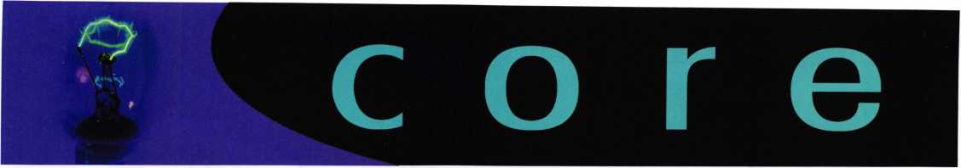

All Tubular Locks are Not Created Equal!

After reading many of the articles surrounding the Kryptonite bike lock, it wasn't until I read the mention in the November issue which inspired me to respond.

I am surprised by the Kryptonite spokeswoman's statement, "It's anything with a tubular cylinder"! I am also surprised that their parent company, Ingersoll Rand, who has many years of expe­rience in security would allow this individual to make such an accusation about all tubular cylinders.

It is very clear that several of the Kryptonite products using .500 tubular cylinders had a design flaw which allowed this unfortunate circumstance to happen. In an effort to reduce costs on their products to compete in the marketplace, they forgot the most important part of manufacturing. When you reduce the overall size of a security lock cylinder from its original size, you need to pay special attention to closer tolerances, special drivers and top tumblers along with driver springs for pick resistance. It would appear this was not done.

I have been in the tubular lock manufacturing business for over 28 years and during this time supplied many cylinders to Kryptonite and other companies who have made the tubular lock a standard for its affordable security and craftsmanship. If you ask any professional locksmith, he will tell you that a prop­erly-designed and built tubular lock is tough to beat.

The claim about a Bic pen on all tubular locks by Kryptonite is simply not true. It is unfortunate that their spokeswoman made a comment which denigrates other tubular lock products which they are not familiar with.

I think the public should know that many, if not most of the tubular lock products in the field perform very well to prevent unauthorized entry. Certainly, the products manufactured by our company do just that.

Sincerely,

Dale N. Padjen Camlock Systems.

Notes on a December 2004 Keynotes Article

Regarding "The Job the Other Guys Didn't Want." by Greg Perry CML, CPS.

Photo #12 has a very obvious life safety code issue. There should be one locking device on the door. The Adams-Rite lock should have been made inactive by replacing the cylinder with a dummy or removing the lock completely and filler plates installed.

John G. Fenner, Sr.

Your concern about photo 12 was handled by initially turning the cylinders over as mentioned in paragraph 2 of the article.

A couple of days later we replaced the upside cylinders with dummys. My apologies, the picture was obviously taken before we installed the exit devices and at the end of the job we turned them over. I guess I should have added a note to the captions about turning the cylinders over.

Greg Perry, CML, CPS

New Certifications

|  |  |  |
| --- | --- | --- |
| **CMLs:** | **CPLs:** | **CRLs:** |
| FULLER, MARK W. | COSTLEY, ERIC A | ROSENBACH, DOUG |
| BOWMAN, DALE | FULLER, HANK P | HEFNER, JOHNNY A |
|  | SMITH, RONALD R. | NASZEK, TIMOTHY |
|  | EATMON, THOMAS L. | DELANEY, JEFF A. |
|  | RINK, LEE W.  MCMENIMON, BARRY L | HOLLINGSWORTH, PHILIP A.  PHELPS, ANDY  BEASLEY, MARVIN  CASPER, RICHARD F.  GRAVITT, RUSSELL M.  MCDADE, ANTHONY F. |

SELCIS, ROBERTO

A Practical Guide to Biometrics Security Technology

by Simon Liu, PhD and Mark Silverman (© 2001 IEEE. Reprinted, with permission, from IEEE and the authors)

WHAT IS A BIOMETRIC

As organizations search for more secure authentication methods for user access, e-commerce, and other security applications, biometrics is gain­ing increasing attention. But should your company use biometrics? And, if so, which ones should you use and how do you choose them? There is no one best biometric technology. Different applications require differ­ent biometrics.

To select the right biometric for your situation, you will need to navi­gate through some complex vendor products and keep an eye on future developments in technology and standards. Your options have never been more diverse. After years of research and development, vendors now have several products to offer. Some are relatively immature, having only recently become commercially available, but even these can sub­stantially improve your company's information security posture. We briefly describe some emerging biometric technologies to help guide your decision making.

The security field uses three different types of authentication:

* something you know—a password, PIN, or piece of personal infor­mation (such as your mother's maiden name);
* something you have—a card key, smart card, or token (like a SecurlD card); and/or
* something you are—a biometric.

Of these, a biometric is the most secure and convenient authentication tool. It can't be borrowed, stolen, or forgotten, and forging one is prac­tically impossible. (Replacement part surgery, by the way, is outside the scope of this article.)

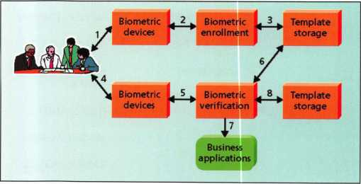

Figure 1. How a biometric system works.

(1) Capture the chosen biometric; (2) process the biometric and extract and enroll the biometric template; (3) store the template in a local repository, a cen­tral repository, or a portable token such as a smart card; (4) live-scan the chosen biometric; (5) process the biometric and extract the biometric template; (6) match the scanned biometric against stored templates; (7) provide a matching score to business applications; (8) record a secure audit trail with respect to system use.

Biometrics measure individuals' unique physical or behavioral character­istics to recognize or authenticate their identity. Common physical bio­metrics include fingerprints; hand or palm geometry; and retina, iris, or facial characteristics.

Behavioral characters include signature, voice (which also has a physical component), keystroke pattern, and gait. Of this class of biometrics, technologies for signature and voice are the most developed.

Fingerprints

A fingerprint looks at the patterns found on a fingertip. There are a vari­ety of approaches to fingerprint verification. Some emulate the tradi­tional police method of matching minutiae; others use straight pattern­matching devices; and still others are a bit more unique, including things like moirefringe patterns and ultrasonics. Some verification approaches can detect when a live finger is presented; some cannot.

A greater variety of fingerprint devices is available than for any other biometric. As the prices of these devices and processing costs fall, using fingerprints for user verification is gaining acceptance—despite the com­mon-criminal stigma.

Fingerprint verification may be a good choice for in-house systems, where you can give users adequate explanation and training, and where the system operates in a controlled environment. It is not surprising that the workstation access application area seems to be based almost exclu­sively on fingerprints, due to the relatively low cost, small size, and ease of integration of fingerprint authentication devices.

Hand Geometry

Hand geometry involves analyzing and measuring the shape of the hand. This biometric offers a good balance of performance characteris­tics and is relatively easy to use. It might be suitable where there are more users or where users access the system infrequently and are per­haps less disciplined in their approach to the system.

Accuracy can be very high if desired, and flexible performance tuning and configuration can accommodate a wide range of applications. Organizations are using hand geometry readers in various scenarios, including time and attendance recording, where they have proved extremely popular. Ease of integration into other systems and processes, coupled with ease of use, makes hand geometry an obvious first step for many biometric projects.

Retina

A retina-based biometric involves analyzing the layer of blood vessels sit­uated at the back of the eye. An established technology, this technique involves using a low-intensity light source through an optical coupler to scan the unique patterns of the retina. Retinal scanning can be quite accurate but does require the user to look into a receptacle and focus on

Keynotes • January 2005

a given point. This is not particularly convenient if you wear glasses or are concerned about having close contact with the reading device. For these reasons, retinal scanning is not warmly accepted by all users, even though the technology itself can work well.

Iris

An iris-based biometric, on the other hand, involves analyzing features found in the colored ring of tissue that surrounds the pupil. Iris scan­ning, undoubtedly the less intrusive of the eye-related biometrics, uses a fairly conventional camera element and requires no close contact between the user and the reader. In addition, it has the potential for higher than average template-matching performance. Iris biometrics work with glasses in place and is one of the few devices that can work well in identification mode. Ease of use and system integration have not traditionally been strong points with iris scanning devices, but you can expect improvements in these areas as new products emerge.

Face

Face recognition analyzes facial characteristics. It requires a digital cam­era to develop a facial image of the user for authentication. This tech­nique has attracted considerable interest, although many people don't completely understand its capabilities. Some vendors have made extrava­gant claims—which are very difficult, if not impossible, to substantiate in practice—for facial recognition devices. Because facial scanning needs an extra peripheral not customarily included with basic PCs, it is more of a niche market for network authentication. However, the casino industry has capitalized on this technology to create a facial database of scam artists for quick detection by security personnel.

Signature

Signature verification analyzes the way a user signs her name. Signing features such as speed, velocity, and pressure are as important as the fin­ished signature's static shape. Signature verification enjoys a synergy with existing processes that other biometrics do not. People are used to signatures as a means of transaction-related identity verification, and most would see nothing unusual in extending this to encompass bio­metrics. Signature verification devices are reasonably accurate in opera­tion and obviously lend themselves to applications where a signature is an accepted identifier. Surprisingly, relatively few significant signature applications have emerged compared with other biometric methodolo­gies. But if your application fits, it is a technology worth considering.

Voice

Voice authentication is not based on voice recognition but on voice-to- print authentication, where complex technology transforms voice into text. Voice biometrics has the most potential for growth, because it requires no new hardware—most PCs already contain a microphone. However, poor quality and ambient noise can affect verification. In addition, the enrollment procedure has often been more complicated than with other biometrics, leading to the perception that voice verifica­tion is not user friendly. Therefore, voice authentication software needs improvement. One day, voice may become an additive technology to finger-scan technology. Because many people see finger scanning as a higher authentication form, voice biometrics will most likely be relegat­ed to replacing or enhancing PINs, passwords, or account names.

USES FOR BIOMETRICS

Security systems use biometrics for two basic purposes: to verify or to identify users. Identification tends to be the more difficult of the two uses because a system must search a database of enrolled users to find a match (a one-to-many search). The biometric that a security system employs depends in part on what the system is protecting and what it is trying to protect against.

Physical Access

For decades, many highly secure environments have used biometric technology for entry access. Today, the primary application of biomet­rics is in physical security: to control access to secure locations (rooms or buildings). Unlike photo identification cards, which a security guard must verify, biometrics permit unmanned access control. Biometric devices, typically hand geometry readers, are in office buildings, hospi­tals, casinos, health clubs, and even a Moose lodge. Biometrics are useful for high-volume access control. For example, biometrics controlled access of 65,000 people during the 1996 Olympic Games, and Disney World uses a fingerprint scanner to verify season-pass holders entering the theme park.

Engineers are developing several promising prototype biometric applica­tions to support the International Air Transport Association's Simplifying Passenger Travel (SPT) initiatives. One such program is EyeTicket, which Charlotte/Douglas International Airport in North Carolina and Flughafen Frankfurt/Main Airport in Germany are evalu­ating. EyeTicket links a passenger's frequent-flyer number to an iris scan. After the passenger enrolls in the system, an unmanned kiosk per­forms ticketing and check-in (without luggage).

The US Immigration and Naturalization Service's Passenger Accelerated Service System uses hand geometry to identify and process preenrolled, low-risk frequent travelers through an automated immigration system. Currently deployed in nine international airports, including Washington Dulles International, this system uses an unmanned kiosk to perform citizenship-verification functions.

Virtual Access

For a long time, biometric-based network and computer access were areas often discussed but rarely implemented. Recently, however, the unit price of biometric devices has fallen dramatically, and several designs aimed squarely at this application are on the market. Analysts see virtual access as the application that will provide the critical mass to move biometrics for network and computer access from the realm of sci­ence-fiction devices to regular system components. At the same time, user demands for virtual access will raise public awareness of the security risks and lower resistance to the use of biometrics.

Physical lock-downs can protect hardware, and passwords are currently the most popular way to protect data on a network. Biometrics, howev­er, can increase a company's ability to protect its data by implementing a more secure key than a password. Using biometrics also allows a hier­archical structure of data protection, making the data even more secure: Passwords supply a minimal level of access to network data; biometrics, the next level. You can even layer biometric technologies to enhance security levels.

Keynotes • January 2005

**11**

E-commerce Applications

E-commerce developers are exploring the use of biometrics and smart cards to more accurately verify a trading party's identity. For example, many banks are interested in this combination to better authenticate customers and ensure nonrepudiation of online banking, trading, and purchasing transactions. Point-of-sales (POS) system vendors are work­ing on the cardholder verification method, which would enlist smart cards and biometrics to replace signature verification. MasterCard esti­mates that adding smart-card-based biometric authentication to a POS credit card payment will decrease fraud by 80 percent.

Some are using biometrics to obtain secure services over the telephone through voice authentication. Developed by Nuance Communications, voice authentication systems are currendy deployed nationwide by both the Home Shopping Network and Charles Schwab. The latter's market­ing catch phrase is "No PIN to remember, no PIN to forget."

Covert Surveillance

One of the more challenging research areas involves using biometrics for covert surveillance. Using facial and body recognition technologies, researchers hope to use biometrics to automatically identify known sus­pects entering buildings or traversing crowded security areas such as air­ports. The use of biometrics for covert identification as opposed to authentication must overcome technical challenges such as simultane­ously identifying multiple subjects in a crowd and working with unco­operative subjects. In these situations, devices cannot count on consis­tency in pose, viewing angle, or distance from the detector.

THE FUTURE OF BIOMETRICS

Although companies are using biometrics for authentication in a variety of situations, the industry is still evolving and emerging. To both guide and support the growth of biometrics, the Biometric Consortium formed in December 1995. The recent Biometric Consortium annual conference highlighted two important areas.

Standardization

The biometrics industry includes more than 150 separate hardware and software vendors, each with their own proprietary interfaces, algorithms, and data structures. Standards are emerging to provide a common soft­ware interface, to allow sharing of biometric templates, and to permit effective comparison and evaluation of different biometric technologies.

The BioAPI standard released at the conference, defines a common method for interfacing with a given biometric application. BioAPI is an open-systems standard developed by a consortium of more than 60 ven­dors and government agencies. Written in C, it consists of a set of func­tion calls to perform basic actions common to all biometric technolo­gies, such as

* enroll user,
* verify asserted identity (authentication), and
* discover identity.

Not surprising, Microsoft, the original founder of the BioAPI Consortium, dropped out and developed its own BAPI biometric inter­face standard.

Another draft standard is the Common Biometric Exchange File Format, which defines a common means of exchanging and storing tem­plates collected from a variety of biometric devices. The Biometric Consortium has also presented a proposal for the Common Fingerprint Minutia Exchange format, which attempts to provide a level of interop­erability for fingerprint technology vendors.

Biometric assurance—confidence that a biometric device can achieve the intended level of security—is another active research area. Current met­rics for comparing biometric technologies, such as the crossover error rate and the average enrollment time, are limited because they lack a standard test bed on which to base their values. Several groups, includ­ing the US Department of Defense's Biometrics Management Office, are developing standard testing methodologies. Much of this work is occurring within the contextual framework of the Common Criteria, a model that the international security community developed to standard­ize evaluation and comparison of all security products (Kimberly Caplan, "Building an International Security Standard," IT Professional, Mar.-Apr. 1999).

Hybrid Technology Uses

One of the more interesting uses of biometrics involves combining bio­metrics with smart cards and public-key infrastructure (PKI). A major problem with biometrics is how and where to store the user's template. Because the template represents the user's personal characters, its storage introduces privacy concerns. Furthermore, storing the template in acen- tralized database leaves that template subject to attack and compromise. On the other hand, storing the template on a smart card enhances indi­vidual privacy and increases protection from attack, because individual users control their own templates.

Vendors enhance security by placing more biometric functions directly on the smart card. Some vendors have built a fingerprint sensor direcdy into the smart card reader, which in turn passes the biometric to the smart card for verification. At least one vendor, Biometric Associates, has designed a smart card that contains a fingerprint sensor direcdy on the card.This is a stronger secure architecture because cardholders must authenticate themselves directly to the card.

PKI uses public- and private-key cryptography for user identification and authentication. It has some advantages over biometrics: It is mathe­matically more secure, and it can be used across the Internet. The main drawback of PKI is the management of the user's private key. To be secure, the private key must be protected from compromise; to be use­ful, the private key must be portable. The solution to these problems is to store the private key on a smart card and protect it with a biometric.

In the Smart Access common government ID card program, the US General Services Administration is exploring this marriage of biometrics, smart cards, and PKI technology. The government of Finland is also considering using these technologies in deploying the Finnish National Electronic ID card.

SELECTING A BIOMETRIC TECHNOLOGY

Biometric technology is one area that no segment of the IT industry can afford to ignore. Biometrics provide security benefits across the spec­trum, from IT vendors to end users, and from security system develop­ers to security system users. All these industry sectors must evaluate the costs and benefits of implementing such security measures.

Different technologies may be appropriate for different applications, depending on perceived user profiles, the need to interface with other systems or databases, environmental conditions, and a host of other application-specific parameters (see Table 1).

**12**

Keynotes • January 2005

Ease of Use

|  |  |  |  |  |  |  |  |
| --- | --- | --- | --- | --- | --- | --- | --- |
|  | **Table 1. Comparison of biometrics** | | | | |  |  |
| **Characteristic** | **Fingerprints** | **Hand geometry** | **Retina** | **Iris** | **Face** | **Signature** | **Voice** |
| 1 Ease of Use | High | High | Low | Medium | Medium | High | High |
| | Error incidence | Dryness, dirt, | Hand injury, | Glasses | Poor | Lighting, age, | Changing | Noise, colds, |
|  | age | age |  | lighting | glasses, hair | signatures | weather |
| Accuracy | High | High | Very high | Very high | High | High | High |
| | Cost | * | * | * | * | * | * | * |
| j User acceptance | Medium | Medium | Medium | Medium | Medium | Very high | High |
| | Required  1 security level | High | Medium | High | Very high | Medium | Medium | Medium |
| | Long-term stability | High | Medium | High | High | Medium | Medium | Medium |
| * The large num ber of factors involved m akes a simple cost com pari son impractical. | | | | |  |  |  |

Some biometric devices are not user friend-  
ly. For example, users without proper train-  
ing may experience difficulty aligning their  
head with a device for enrolling and  
matching facial templates.

Error Incidence

Two primary causes of errors affect biomet-  
ric data: time and environmental condi-  
tions. Biometrics may change as an individ-  
ual ages. Environmental conditions may  
either alter the biometric directly (for  
example, if a finger is cut and scarred) or  
interfere with the data collection (for

instance, background noise when using a voice biometric).

Accuracy

Vendors often use two different methods to rate biometric accuracy: false-acceptance rate or false-rejection rate. Both methods focus on the system's ability to allow limited entry to authorized users. However, these measures can vary significantly, depending on how you adjust the sensitivity of the mechanism that matches the biometric. For example, you can require a tighter match between the measurements of hand geometry and the user's template (increase the sensitivity). This will probably decrease the false-acceptance rate, but at the same time can increase the false-rejection rate. So be careful to understand how vendors arrive at quoted values of FAR and FRR.

Because FAR and FRR are interdependent, it is more meaningful to plot them against each other, as shown in Figure 2. Each point on the plot represents a hypothetical system's performance at various sensitivity set­tings. With such a plot, you can compare these rates to determine the crossover error rate. The lower the CER, the more accurate the system.

Generally, physical biometrics are more accurate than behavioral biometrics.

Cost

Cost components include

* biometric capture hardware;
* back-end processing power to maintain the database;
* research and testing of the biometric system;
* installation, including implementation team salaries;
* mounting, installation, connection, and user system integration costs;
* user education, often conducted through marketing campaigns;
* exception processing, or handling users who cannot submit read­able images because of missing appendages or unreadable prints;
* productivity losses due to the implementation learning curve; and
* system maintenance.

User Acceptance

Generally speaking,  
the less intrusive the  
biometric, the more  
readily it is accepted.

However, certain user  
groups—some reli-  
gious and civil-liber-  
ties groups—have  
rejected biometric  
technologies because  
of privacy concerns.

Required  
Security Level

Organizations should  
determine the level of

security needed for the specific application: low, moderate, or high. This  
decision will greatly impact which biometric is most appropriate.  
Generally, behavioral biometrics are sufficient for low-to-moderate secu-  
rity applications; physical biometrics, for high-security applications.

Long-term Stability

Organizations should consider a biometric's stability, including maturity of the technology, degree of standardization, level of vendor and govern­ment support, market share, and other support factors. Mature and standardized technologies usually have stronger stability.

Biometric technology has been around for decades but has mainly been for highly secretive environments with extreme security measures. The technologies behind biometrics are still emerging. This article gives a snapshot of the dynamics under way in this emerging biometric market, and we hope it will help you consider all the possible alternatives when acquiring new biometric technologies.

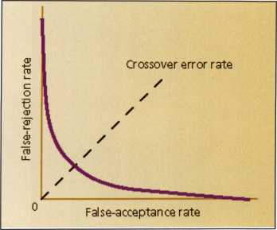

Chart showing crossover error rate in  
biometric accuracy

Figure 2. Crossover error rate attempts to combine two  
measures of biometric accuracy.

Keynotes • January 2005



**Biometrics Resources**

**at Vour Fingertips**

ADEL

<http://www.ollproducts.com/manufacture99/adellock/supplier>, html

ADEL fingerprint technology includes three categories: optical fingerprint reader technology, fingerprint verifi­cation algorithm technology which obtains a state invention patent, and build-in application technology (TIDSP technology). Adel fingerprint technology prod­ucts include: fingerprint locks, fingerprint safes and fingerprint Bio-Guard or Bio-pass to PC. Adel finger­print technology also offers a platform for the second time development in many fields. Our Adel solution, your Ideal selection.

Association for Biometrics

<http://www>. afb. org. uk/

Aims to promote the awareness and development of biometrics-related technologies. It provides an interna­tional forum for research and development, system design and integration, application development, market development, and other issues.

Avanti

<http://www>. securityconfig. com/resources/biometrics/a vonti.htm

A reference site for biometrics, Avanti contains con­siderable amount of background information about biometrics, their use in everyday business situations and how to deploy them.

Axxis Biometrics

<http://www>. axxisbiometrics. com/

Axxis Biometrics is a technology dealer committed to selling biometric products that utilize the fingerprint as a unique form of identification. They offer fingerprint door locks and other biometric fingerprint products that are leading technologies in the biometric security industry. Simply click on the pictures of the biometric fingerprint door locks and other biometric security products below for a detailed description. Check out the Services page if you are a Contractor or Developer looking for Bid Support pricing on biomet­ric locks for your large projects.

**14**

Keynotes • January 2005

BlO-key

<http://bio-key>. com/

BlO-key develops and licenses advanced biometric finger identification technologies that are cost effec­tive, scalable and easy to deploy. BlO-key products provide 'True User Identification™' for the prevention of data and identity theft while preventing false alias­es. BlO-key pioneered the only finger identification algorithm that has been certified by the ICSA, and today continues that innovation by offering cost effec­tive, high-performance one-to-many finger and one-to one identification solutions, that provide security and positive identification for both government and enter­prise applications.

The Biometrics Catalog

<http://www.biometricscatalog.org/>

The Biometrics Catalog is a U.S. Government spon­sored database of information about biometric tech­nologies including research and evaluation reports, government documents, legislative text, news articles, conference presentations, and vendors/consultants. Adding and retrieving information in the Biometrics Catalog is free and encouraged.

The Biometric Consortium

<http://www.biometrics.org/>

Serves as the US government's focal point for research, development, test, evaluation, and application of biometric-based personal identi­fication and verification technologies.

Biometrics Direct

<http://www>. biometricsdirect. com/

Biometrics Direct is committed to providing rel­evant, readily useable biometric solutions into homes and workplaces to improve the quality of life, enhance personal security and empow­er personal privacy. As an authorized SAFLINK solutions provider, Biometrics Direct incorporates multiple biometric methods and devices into a cohesive network biometric authentication solution to meet our clients most rigorous requirements. Biometrics Direct fea­tures biometric solutions for facility, personal security, corporate data and network access.

Biometrics USA

<http://www>. biometrics-usa.com/

This site features affordable fingerprint locks, plus Biometrics 101 information and a biometrics FAQ sheet

bioSecure

<http://www>. bio-secure, us/biosecure/about, htm

bio-SECURE™ produces, markets, and distributes a line of biometric safes and safe storage devices. These safes and devices incorporate a "bio- SECURE™" biometric activation module proprietary to bio-SECURE. During the summer of 2002, bio- SECURE staff members developed and demonstrated a pre-production design of the first commercially viable biometrically activated safe. This groundbreak­ing safe eliminates unauthorized access to firearms, jewelry and valuables utilizing the "bio-SECURE™" biometric locking device. The locking device contains a fingerprint scanner and a processing device that verify that the individual is the authorized user of the bio-SECURE™ Safe by reading his or her actual fin­gerprint and comparing the scanned print with finger­print data stored within the device.

Professional Business Products

We donate 5% of all sales to the  
**ALOA Scholarship Fund**Buying from WEBS®?

We offer lower prices on invoices/workorders, checks,  
repair lags, magnets, business cards, key lags and more.

[www.pbp2000.com](http://www.pbp2000.com)

Keynotes • January 2005



Cogent Systems

<http://www>. cogentsystems. com/

Cogent is a leading provider of Automated Fingerprint Identification Systems, or AFIS, and other fingerprint biometric solutions to governments, corporations, law enforcement agencies and other organizations world­wide. Our solutions enable customers to capture fin­gerprint images electronically, encode fingerprints into searchable files and accurately compare a set of fin­gerprints to a database containing potentially millions of fingerprints in seconds.

Corporate Safe Specialists

<http://www>. corporatesafe. com/fingerprint, asp

Biometrics safes eliminate unauthorized access to firearms, jewelry and valuables through the use of industry leading fingerprint scanning, storage and management technologies. Products feature Quick access, State-of-the-art technology, Quick and easy reconfiguration, Recognition of up to 50 fingerprints, Key back-up

Fingerprint Cards

<http://www.fingerprint.se/page.asp?languagelD=2>

Fingerprint Cards (publ) is established as a leading source of embedded biometric systems (can operate independently of a PC processor); it has also asserted itself successfully as a leading provider of low-cost biometric systems technology with the completion of the two-chip fingerprint verification system based around the FPC1030 swipe sensor.

Find Biometrics.com

<http://www.findbiometrics.com/>

Features vendor information, news and helpful guides: a comprehensive glossary, What are "Biometrics"?, Biometrics Glossary, Biometrics in the 21st Century, Biometrics 101, Identification vs Verification, Choosing a Biometric Solution

Global Sources

<http://www.globalsources.com/manufacturers/Fingerprint->

Lock.htmi

A clearinghouse of biometric lock products, this site features industry information, online publications and a user-specific catalog feature.

The Home Security Store

www. HomeSecurityStore

Seller of home security products including fingerprint locks.

International Biometric Industry Association

<http://www>. ibia. org/

A trade association founded in September 1998 in Washington, D.C., to advance, advocate, defend, and support the biometric industry's collective interna­tional interests. Governed by and for biometric devel­opers, manufacturers, and integrators, IBIA aims to serve all biometric technologies in all applications.

Journal of the International Biometric Society

[http](http://s)**[://s](http://s)** tat. tamu. edu/Biometrics/

Published quarterly, Biometrics aims to promote and extend the use of mathematical and statistical meth­ods in various disciplines. It describes and exempli­fies developments in these methods and their applica­tion for experimenters and those primarily concerned with data analysis.

The Keyless Lock Store

<http://www.nokey.com/biomfinlocst.html>

This company features a unique fingerprint door lock along with resources for installation and setup.

Saflink

<http://www.saflink.com/physical/>

Offers two primary solutions: SAFpassage, a full-fea­tured biometric access control system, and SAFcard which allows you to add biometric protection into your existing physical access system.

SENSE Holdings, Inc.

<http://www>. senseme. com/

SENSE Holdings Inc. is a leading provider of biomet­ric identification systems. SENSE integrates cutting- edge biometric technology into mechanical and elec­tronic devices that improve many business processes including Homeland Security applications , Time and Attendance, Access Control, SmartCard Technology, Biometric Identification and Secure Log-on.

**16**

Keynotes • Jsnuary 2005

A NEW DAY HAS DAWNED

ON THE

INFORMATION HIGHWAY

*m*,*

**P;**

sSkvv. :-i

iw*«. *\*\*&$&&* s •\**

ffm* UH* Krs \ **,*v rroy. p ^**

**$«- *&»* a? s iTvikf >** VSxM

&*p* * < .sty  
4 •!>*r ’..

I

I

I

**featuring:**

- a fresh new look

* new message boards
* download prp info for specific sittings
* choose your own password to the  
  members only section
* improved locksmith search at  
  findalocksmith.com.
* and much more! •"•• -;T-



Go Your Own Way

by Greg Perry, CML, CPS

This month we’ll look at a Mosler Class 5 Black Label Vault door. The job was simple enough. My instructions were to open the vault door because the combination was lost. I tried some simple combinations; 50, **50-25-50,** 10 - 20 - 30 etc. with no luck. Since this door came from the factory with an S&G 8560 Group 1R manipulation proof lock, I decided it was drill time.

On a GSA door, if the label is to be maintained, holes must be placed under the dial ring. In addition, a hole must be repaired properly.

How would you drill it?

If you are unfamiliar with this lock you might be surprised when trying to dial it. Sargent and Greenleaf designed the lock a little different than most safe locks. The proper way to open the lock is to dial the combination like most locks: 4xL, 3xR, 2xL then dial right to 0. Next, push the dial in and release. Then, contin­ue right to retract the bolt. The push-in movement of the dial moves the drive cam towards the back of the lock to release an accelerator spring attached to the lever assembly from a catch on the lock case. This action moves the fence into the wheel pack. If the gates of the wheels are aligned under the fence, the lever nose will be in the drive-cam cutout and the dial can be turned to retract the lock bolt. If the gates are not under the fence, a sec­ond S-shaped spring will lift the lever nose off the wheel pack and drive cam. This is how manipulation resistance is achieved.

The first choice is to remove the dial or drill through the dial. Each has an advantage and a disadvantage. Drilling though the dial makes sense if you use a lever rig and want to drill at drop in. The lock has a rear drive cam and looking through the hole into the lock case at drop in is easy. First, pin the dial at 0 (the spyproof ring makes it easy). In the past, I’ve used a pair of screwdrivers wedged on both sides, although a better technique is to drill a hole through the dial ring and use a screw to keep the dial from moving. Once the hole is drilled, simply dial four times to the left, stopping at 5. Then, return the dial to 0 and look into the hole. If you see a gate, or portion of the gate, cen­ter it to the hole and you will know the first number. If you don’t see the gate, turn the dial left to 10 then back to the 0 to look in the hole. Continue moving the wheel pack five numbers at a time until you find the first number. Sometimes, as you are looking for the first number, you will be able to see the gate of wheel number two. If you do see it, record the number. If not,

once the first number is found, dial right four times to a number five numbers or so below your first number, then back left to 0. Look in the hole. If you do not see the second gate, turn the dial back right, moving five numbers further down the dial. As before, turn left back to 0 to look in the hole. For example, if the first number you found is 67, start looking for the second number at 60, then 55, 50 etc. Once you find the edge of a gate, center it. Finally, dial the first two numbers and look for the last number. Start turning the dial left to a number about 5 higher than the second number, then back to 0. Once you’ve found a gate on the third wheel, center it. Push the dial in and release. The lever should have dropped into the wheel pack and you can now continue turning right to retract the lock bolt.

The second option is to remove the dial. This dial will not pull. That leaves two remaining removal options. The First, is to grab the dial knob with locking pliers and rock it off. This can be a little dangerous if the spindle breaks off below the face of the door. A better option is to drill down the center of the dial and drill away the spindle until the dial can be removed. This leaves a very short section of the spindle, enough to grab with locking pliers but just barely. I prefer this method.

Once the dial is removed there are several options for a drill location. The most common option is drop in or 7/8” at 97.

This door was drilled there sometime in the past (poorly). After removing the dial, I found a 3/8” hole was drilled at the drop in location. I chucked up a carbide bit to see if I could freehand drill into the lock case. The bit dulled quickly. I prefer to drill a scope hole. Doing this will help you avoid nicking the first wheel or the fence as you enter the lock case. If you are using the StrongArm Mini-rig template number two hole H or 1 1/2” at about 87 provides a great hole location to view the wheel pack under the fence. Since this door already had a hole at drop in and I really didn’t know how the repair was performed, I decide to drill a new hole. Ten minutes and a single bit later, I was aligning the wheel gates under the fence. Once the combination was dialed in and the lock bolt retracted, I cleaned up my tools.

I then had the customer come over to open the door. (I make this a standard practice as my job is to unlock the container not open it.)

The opening and repairs on this door are specified in Federal Specification 809. A Black label can be repaired with ball bear­ings, hardened drill rods or carbide. So I inserted a carbide pin into the hole I drilled. The existing hole is larger than my car-

**18**

Keynotes • Jenuary 2005

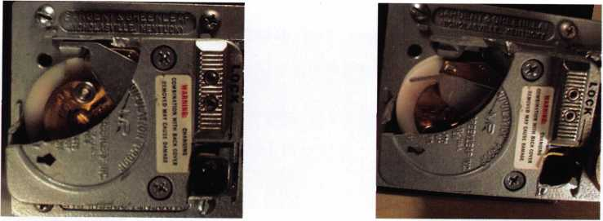

Photo 1 shows a rear view of a different 8560 lock from Photo 2 shows the lever with the accelerator off the catch

my collection of cutaway locks. The catch can be seen in the retracted position,

holding the end of the silver accelerator spring.

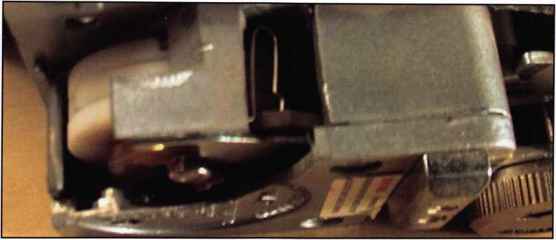

Photo 3 shows the S shaped spring that lifts the lever back off the wheel pack if the wheel gates are not properly aligned.

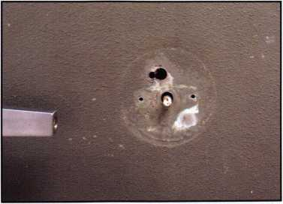

Photo 4 is the first shot of the vault door. The smaller  
hole is the one I drilled.

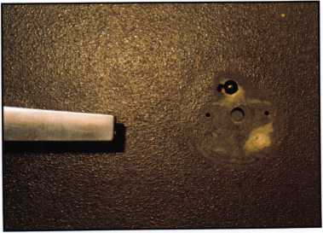

Photo 5 shows the outside ball bearing installed in the  
larger hole. The carbide pin was installed from the back  
to leave some room to weld the ball bearings in the larg-  
er hole.

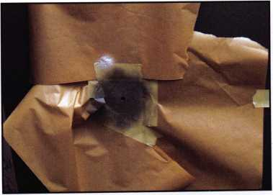

Photo 6 shows the masking after texturing and gray  
paint.

Keynotes • January 2005

**19**

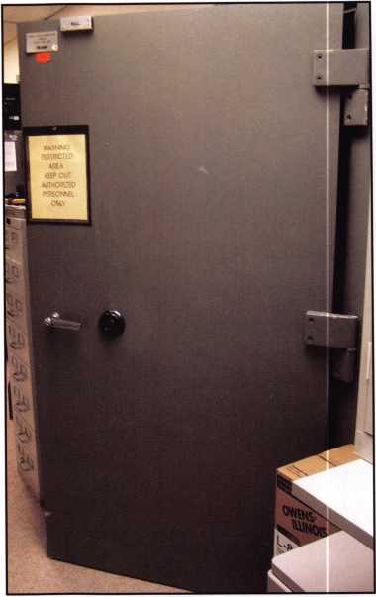

Photo 7 is after the lock was installed and shows a full  
view of the outside of the door.

|  |  |
| --- | --- |
| » OOOA SOUS MUST M TH.OWN ■ TO LOCttO POSITION M OftDtft  | IU ClOSI TNf IOC. BOX COVIX | |
|  | * |
| **►** | • p **l-".** |
| **|g|g.** n |
|  | £ |
| 3*S | ion gSE=5||^j |

Photo 8 is of the inside lock box. The door boltwork is  
locked and the lock bolt is retracted.

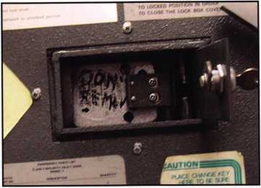

Photo 9 shows the boltwork retracted.

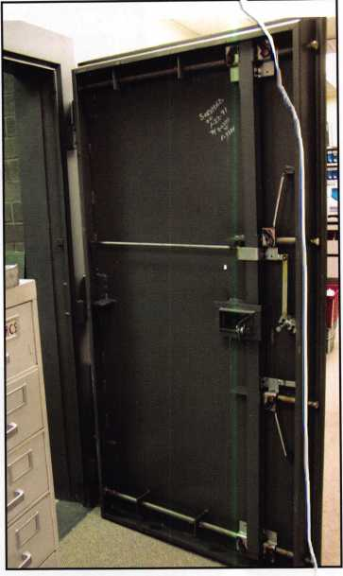

Photo 10 shows a full view of the back with the cover  
plate removed for an understanding of the overall  
operation.

**New!** Keedex Stainless Steel Armored Door Loops

AVAILABLE FROM YOUR KEEDEX DISTRIBUTOR

MADE IN U.S.A.

ALL

STAINLESS STEEL  
DESIGN

FLEXIBLE STAINLESS

STEEL CONDUIT

STAINLESS STEEL  
END PIECES

STAINLESS STEEL  
MOUNTING SCREWS

COSTS NO MORE  
THAN MOST DOOR  
LOOPS THAT HAVE  
PLASTIC END PIECES

Call or write today for your free catalog!

"Ideas That Work"

Keedex, Inc.

12931 Shackelford Lane  
Garden Grove, CA 92841  
714-636-5657 • Fax: 714-636-5680  
e-mail: [info@keedex.com](mailto:info@keedex.com)

[www.keedex.com](http://www.keedex.com)

bide pins so I placed three ball bearings in the hole and welded them in place. The inner surface was also welded and subsequently ground down to a smooth surface. The outer surface was ground smooth, put­tied with auto body glazing compound, and sanded smooth. The next step was to mask off the area outside of the dial ring. I used a stone paint to provide texture. After it dried, a couple of coats of GSA gray paint were applied.

The old lock and dial ring was reinstalled and a new dial was provided. Some of you may be wondering, since this is a GSA Class 5 door, why I didn’t install a KabaMas X07, 8, or 9. The specification FFL2740 that requires the XO type lock is a requirement for storage of classified materials. This door, even though it is a GSA class 5 door, is being used in a pharmacy. The repair still needs to meet the federal requirements in case someone decides to use it later for storage of classified materials. If that happened, the lock would need to be upgraded.

Finding an already-drilled improperly-repaired hole can sometimes make the job easier, especially if you are having trouble determining a good drill point on an older container. But it speaks volumes about the lack of caring and lack of professionalism of the previous technician. Don’t let someone else find your poor- quality work. Do the job right.

Keynotes • January 2005

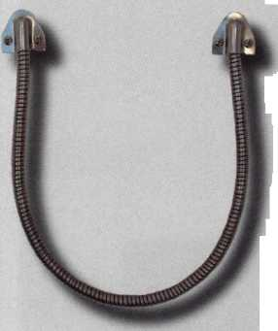

|  |  |
| --- | --- |
|  |  |
|  | **H**  - |
|  |  |
| **■Hi** |  |

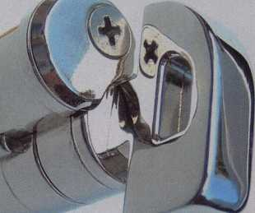

ic **cm** Lhum3eu^n

For all 6 & 7 pin SFIC cylinders including Best, Falcon, Arrow & others.

..use as VA" or VA" mortise thumbturn.

..attach to key ring.

.leave with contractor  
as try-out key.

.carry in toolbox.

Convert..

..Herculite doors  
without pulling them  
down.

..cabinet lock to  
convenient thumb latch  
operation.

.double cylinder lock  
to single cylinder.

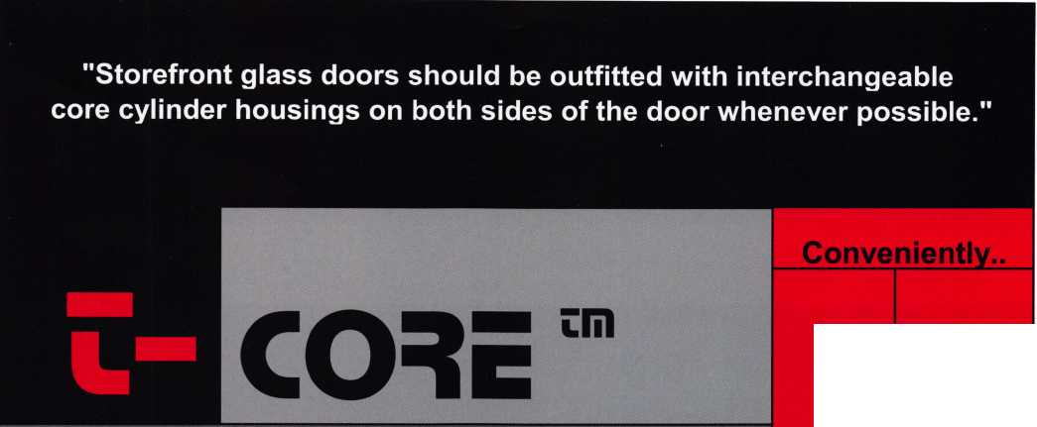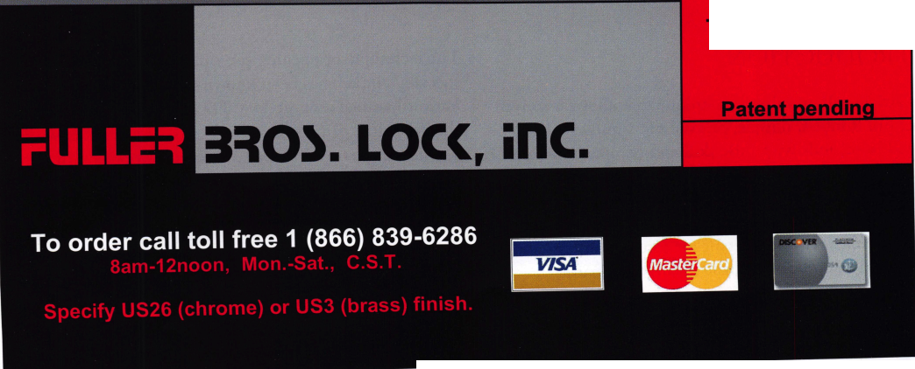

Opening Locks with the “999” or Bump Key

by Marc Weber Tobias

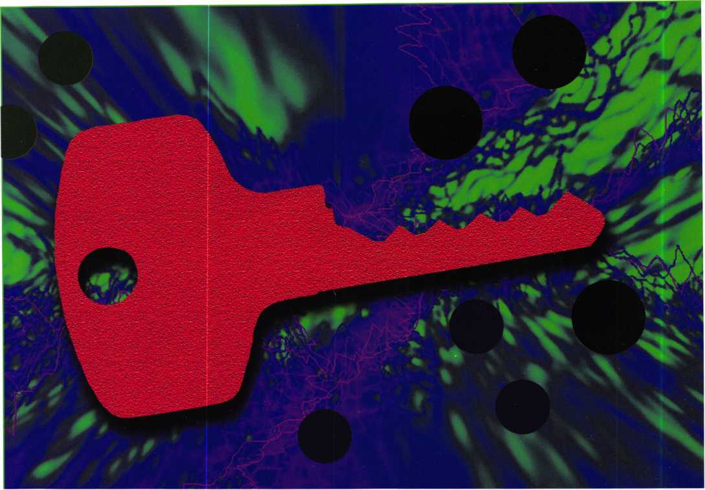

INTRODUCTION

This article will examine a technique that allows a conven­tional pin tumbler, dimple, or axial pin tumbler lock to be opened in seconds with little skill and no apparent dam­age. The procedure poses a real threat to the security of many pin tumbler mechanisms but can also provide the locksmith and rapid entry team with a quick method to open a cylinder. It is important for security professionals to understand the process and the means to defeat it.

The technique of opening pin tumbler locks by using a specially cut key has been known for quite some time. Variously called a bump key, 999 key or percussion key, the procedure can result in the bypass of a cylinder within seconds. I recently attended a weekend workshop in the Netherlands with several experts in various aspects of bypass of high security locks. At that meeting, detailed dis­cussions and demonstrations were provided with regard to the use of the bump key for a variety of cylinders. As a result, a paper was published on the Internet that describes the method to open many European locks.

**22**

Keynotes • January 2005

This issue has received a great deal of attention in Germany and was the subject of a national television pro­gram showing a locksmith opening many door locks on businesses almost instantly. Although some American lock­smiths are familiar with the practice, the general public is not aware of the potential problems inherent in pin tum­bler locks. I will summarize the relevant issues and dispel some of the misinformation that presently exists regarding the technique. The topic was fully described in the latest edition of LSS+ (Version 5.0). Additional in-depth treat­ment and video has been inserted into Version 5.1, sched­uled for release in 2005.

THEORY OF THE BUMP KEY

A bump key can only work with a split pin tumbler lock­ing mechanism because a shear line must be present and a gap in that shear line must be created by the action of the impact upon each pin. Certain locks cannot be opened because of their mechanical design and will be detailed subsequently in this article.

A famous English physicist, Sir Isaac Newton, can be cred­ited for first describing the premise upon which the bump key is based. Little did he know that his Third Law of Motion would be responsible for opening many of the high security locks two centuries after he first published his theory. The law of physics which is familiar to most sci­ence students, states “for every action, there is an equal and opposite reaction.” As discussed in LSS+, it explains why all impact picking tools can cause a lock to open.

Mechanical and electric pick guns create an impact or shock at the base of each bottom pin in each chamber, which in turn causes the next pin in the pin stack to bounce for a few milliseconds. When done correctly, there will be created a momentary gap between each bottom pin and the pin above it. If torque is applied at the precise moment, this gap can be exploited to remove all pins from blocking rotation of the plug. For a brief instant, the shear line is open.

In order to properly cause this to occur, three actions must happen simultaneously. First, the precise amount of torque must be applied that will cause binding of the bottom pin that comes into contact with the impact device (but not bind the next pin) so it can bounce within its chamber. If too little or too much tension is applied, the process will not work. Second, sufficient impact must be presented to the base of each pin and the correct amount of energy must be transferred to the pin above it at the same time as all other pins. Finally, there can be no impediment to movement of each of the pins.

THE DESIGN OF THE BUMP KEY

Conventional pin tumbler, dimple, and some axial pin tumbler locks can be opened with specially cut keys, as shown.

Conventional pin tumbler locks

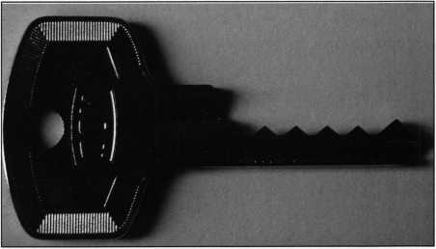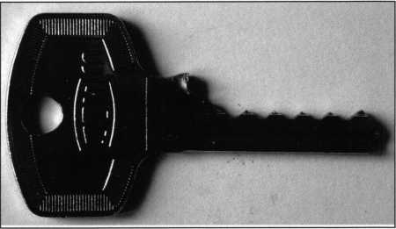

The standard bump key requires that all cuts be made  
to the deepest value.

The bump key must transfer energy to all pins simultane­ously. In order to accomplish this, the bitting must be spe­cially created to make equal contact upon impact. There are two primary means to accomplish this with a conven­tional pin tumbler lock; in both instances, a blank is cut to the deepest code value for each pin position. In the pre­ferred method, the shoulder is trimmed about .5mm. This will allow a forward movement of the key when it is seated under each pin. In the original technique, the “999” key (so named because nine denoted the deepest possible cut), was withdrawn from the keyway by one pin prior to rap­ping. As it was forced forward, it would contact each pin with force.

Keynotes • January 2005

Dimple locks

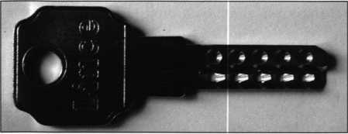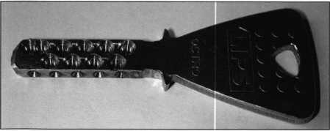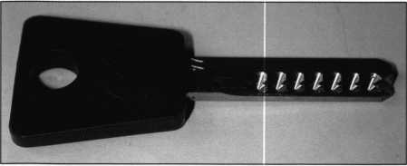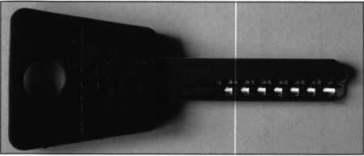

Dimple locks, even high security systems, can be opened with a bump key. Shown are examples of four different keys. Note that all cuts in all positions are made to their lowest value. In certain cases, even telescoping pins can be opened.

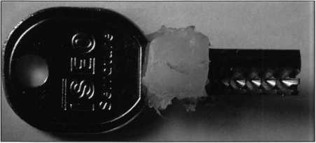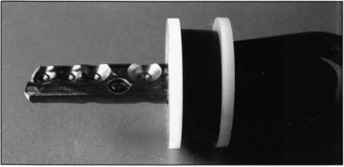

A shoulder is created by glue or a rubber seal for use on bump keys because they do not have any way to stop forward motion. Rubber bands or cable ties can also be utilized.

Axial pin tumbler locks

Tubular locks can be bypassed by the same technique as conventional pin tumbler locks. In fact, they can be easier to open because there is equal access to all pins without the problem of forward movement of the key within each cut.

The author has had good luck with five pin locks; six and seven pin mechanisms can be opened less reliably. Tubular keys were cut so that all positions had the maximum depth, and cuts were made extra wide so the pins would not bind when torque was applied. Note that the top por­tion of the keyway index pin must be removed or the key will not be able to turn.

A dimple lock, even certain high security models, can be opened with a bump key as shown. All of the pin positions must be cut to their deepest value, and the end of the key must be trimmed approximately .25-.5mm, to allow for­ward movement. A stop made of rubber bands or insulator can be effective. Another technique is to utilize a glue gun to create a shoulder, as shown.

**24**

Keynotes • January 2005

HOW TO OPEN A LOCK WITH A BUMP KEY

In order for a lock to be successfully opened, energy must be transferred to the base of each pin at the same time.

A key that is specially cut provides the means to transmit the shock to each tumbler. There are two recognized methods to bypass a cylinder with a bump key: withdrawal of the key by one chamber position (pull-back) and creating a forward path for the key to transfer energy to the pins by reducing the shoulder length (negative shoulder). There are also two methods to apply energy to the head of the key when using the negative shoulder method: create a forward movement of the key of up to .5mm, which transfers energy to the pins; or seat the key slightly off center from the base of the root of each cut so that the pins are resting against each pin when the key is struck. This will transmit a shock to each pin without the key appreciably moving forward.

Pull Back-Method

The original method of utilizing the bump key required that the bitting be cut to the deepest cut in each position. The key would be fully inserted into the plug, then with­drawn one position. Torque would be applied and the head of the key would be rapped with a plastic or wooden mal­let, causing energy to be transmitted to each pin. Although this procedure is fairly reliable, there could be a problem with the last bitting position not making proper contact with the adjacent pin tumbler. The preferred method is described in the next section.

Negative Shoulder Method #1

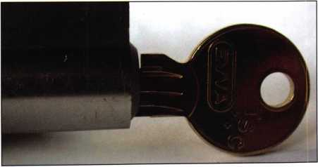

Up to .5mm is trimmed from the shoulder to allow the ramps of each cut to make contact with the base of each pin.

This method is more reliable than the pull-back techniqu because the interface between the bitting of the key and the base of each pin is constant. A key with each bitting position having the deepest cuts is prepared. Then, the shoulder is trimmed approximately .25mm-.5mm, which will allow the key to be moved forward enough that the base of each pin can make contact with the ramp of each cut. When shock is applied to the key head, the key will move forward until stopped by the shoulder. Torque musi be properly applied in order to open the lock. The advan­tage of this technique is that the key will always return to its “home position” when torque is released, allowing for rapid reapplication of energy. Note that if too much mate rial is removed from the shoulder, the pins may be lifted too high before shock is applied.

Negative Shoulder Method #2

The negative shoulder method #2 utilizes the same basic key design as shown in Figure 4. To open the lock, the ke is first pushed forward until it is stopped by the shoulder, resulting in each of the pins making contact with the ramps of their associated cut. Torque is applied and the head of the key is rapped. This method requires virtually no forward movement of the key.

Critical Design Issues of the Bump Key for Conventional Pin Tumbler Locks

Whether the pull-back or negative shoulder method is uti lized, there are three critical issues in the design of the bump key: the centering of each bottom pin at the root, the distance between the center of the root and the associ­ated ramp, and the angle of the ramp. If keys are not cut correctly, the lock will be difficult or impossible to open.

Each pin must be centered within the root for its cut. Thi is especially important for the pull-back method. If not, then the timing of transmission of energy will not be equ; which could cause the pins to move at different times, resulting in an uneven gap being created at shear line. In addition, the distance between the position of the pin wit relation to the center of the cut and the ramp must be th( same, otherwise the pins will be contacted at different times when a shock is applied to the key head. If the cuts are too wide or misaligned, the key will not work because energy will not be transferred to the base of the pins.

Finally, if the ramp angles are too steep, they will present barrier to the movement of the pin which will result in tl insufficient amount of energy being applied to each pin. The angle of the ramp must be significant enough to engage the pin and allow it to move vertically. It cannot 1

too steep, nor can it be too flat.

Keynotes • January 2005

***2***

the negative shoulder method is employed, then there ould not be more than about .5mm removal of material >m the shoulder because the forward movement of the y and associated vertical movement of the pins could be gher than the shear line. This could occur if the length of e bottom pin was equal to the deepest cut of the key.

ys that are used for this process should be made of nick- silver or steel or brass that will not distort, bend, shear tear upon the application of force.

>me keys do not have shoulders; dimple locks are a per- ct example. In such cases, material is removed from the id of the key to allow slight forward movement, and a iable stop is provided. Rubber bands, rubber insulators • glue from a hot glue gun can be used to create such a op. Dimple locks can present other challenges because Leir internal construction can be damaged by repeated )plication of shock.

pplication of Energy to the Head of the Key

he author has utilized wooden and plastic-handled tools ) apply shock to the head of the key. However, the best >ol appears to be one that was designed by Kurt Zuhlke **l** the Netherlands, which allows controlled force to be :>plied rapidly and easily. This is a plastic mallet with flex­ile material to provide the correct recoil when the blank struck.

ocks that can be opened

irtually all conventional pin tumbler locks are subject to lis method. Manufacturers have employed a variety of :chniques to frustrate bypass by picking, impressioning id decoding through the use of security pins (mushroom, >ool, serrated and similar designs), telescoping pins (pins ithin pins), as well as secondary locking systems that nploy some form of sidebar. These measures will not lake the lock secure against this form of attack.

Extensive testing has been done in Europe, and the follow­ing locks have specifically been identified by Barry Weis (in his White paper that was issued on November 5, 2004) as being subject to compromise. The list is not all inclusive, and the author has also tested many American locks that can be easily opened. It appears that the more expensive locks are easier to open.

Assa Twin 6000

Mul-T-Lock pin-in-pin

Mul-T-Lock interactive

Mul-T-Lock 7x7

LIPS Octro

LIPS Keso

DOM IX KG

DOM 5-pin

EWATSC

Zeiss IKON 5-pin

Corbin 5-pin

ICEO dimple

D.L.C. 5-pin

Lince dimple

ABUS 5-pin

Pfafifenhaim

Schlage five and six pin

Within the class of locks that can be opened are certain sidebar locks and dimple locks, and even locks with tele­scoping pins and security pins.

**6**

Keynotes • January 2005

Forensic Implications and Effect of Applied Force

Locks which are not subject to the practice

Certain locks are not subject to the bump key technique.  
These would include any mechanism with a sidebar or sec-  
ondary locking system, although there is an exception. As  
was noted earlier, rapping is possible because a momentary  
gap is created within each pin stack that is between pin  
segments. If pins cannot be “split” through the application  
of energy, then the lock will not open.

There is a caveat, however. Certain high security locks, such  
as the Assa 6000, can be bypassed if the torque is applied  
while using a portion of the key that has the correct sidebar  
code. This will effectively neutralize the effect of the sidebar  
and allow the lock to be manipulated as a conventional pin  
tumbler device. This appears to be true in any sidebar lock-  
ing device that splits the functions of the side millings and  
conventional bitting. Thus, Medeco locks would not be  
subject to the practice, because the action of the pins to  
control the shear line and sidebar are integrated.

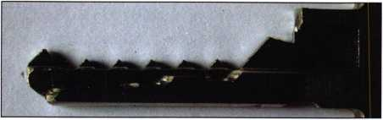

Certain high security sidebar locks can be opened by  
rapping. Shown is a key for the Assa with the proper  
sidebar code. Unless the sidebar and conventional  
bittings are integrated, some of these locks can be  
opened.

Any portion of a locking mechanism that does not employ  
split pin tumblers cannot be opened by this technique.  
Thus, for example, the Emhart interlocking pins, Medeco,  
Assa and Schlage (sidebar portions), Abloy, Ewa 3KS laser  
track and MCS magnetic code system, and Miwa magnetic  
locks would not be subject to compromise.

Interestingly, the better grade of locks are seem to be more  
susceptible to the technique of bumping. Thus, locks with  
higher tolerances and harder metals are opened more easily  
than those of softer metal or sloppy tolerances. In the case  
of metal content, less deformation occurs as shock is  
applied. Higher tolerances appear to result in the more effi-  
cient transmission of energy to the pins. Note that para-  
centric keyways have nothing to do with the resistance of a  
lock to rapping.

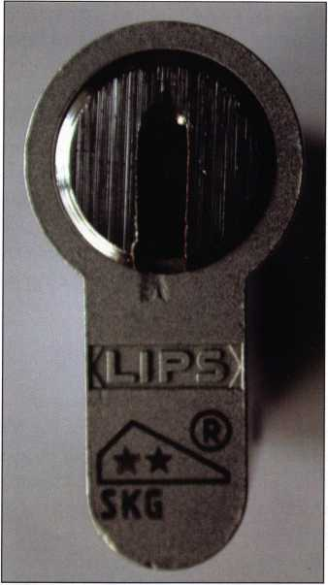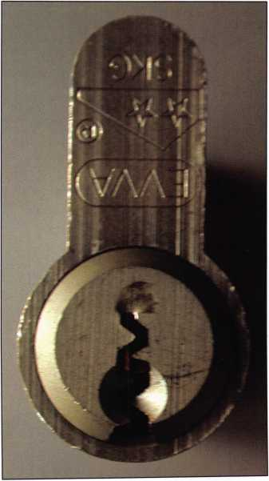

Physical indicia of the use of a bump key can be seen if repeated blows are required to open the lock. Note the inden­tations on the front of these plugs. There may be internal indi­cations as well.

Keynotes • January 2005

**2**

Locks can be damaged by the use of a bump key and will leave traces that they were manipulated, whether they were opened or not. Specifically, the face of the lock can show compression marks, as can the base of each pin. In addition, springs can be compressed with repeated shocks which can cause mechanical failure of the lock. Internal components can also be damaged, which is a particular problem in dim­ple locks. Deformation of the keyway or chambers can also occur and which may cause the key to become lodged within the keyway. Locks with relatively soft plugs or those made of nylon or other non-metallic materials should be viewed with caution, as they may be severely damaged. These issues may be moot however, if the lock can be opened with the applica­tion of force one time, as is often the case.

How to prevent the bump key from working

The use of a bump key to open a lock can be prevented. Moshe Dolev, an Israeli inventor and co-designer of the Mul­t-Lock has patented a solution that works quite well in frus­trating this type of attack. The special spring-biased two-part pin catches within each chamber upon the application of a shock and will prevent the plug from turning. A more detailed discussion of this pin can be found in LSS+, together with a detailed video showing the physical action of the bump key and the way to prevent the movement of the pin within each chamber.

Bump Keys and Security

Most mechanical locks can be bypassed through picking, impressioning or decoding. However, each of these tech­niques require various skill levels that are commensurate with the security of the mechanism. Often, special tools are need­ed. The inherent threat of the bump key is that relatively no skill is necessary to open most conventional pin tumbler mechanisms. Keys can be easily cut to act as a bump key, and the acquisition of blanks, even restricted keyways, is not a significant issue, as has been noted by the author in LSS+, relating to the use of the profile milling machine.

The author has opened high security locks in seconds by rap­ping. In fact, in a recent television interview, the reporter, although totally unskilled in bypass techniques, was able to open a six pin Schlage cylinder in about five seconds. The author views the inherent design of a pin tumbler lock as a potentially serious threat to security. Unless anti-rapping pins are employed, such as developed by Dolev, then the security of any facility that relies upon conventional locks may be at risk. This is an excellent opportunity for locksmiths to take the initiative and educate their customers as to the risks in utilizing locks that do not employ secondary locking systems, such as sidebars, or protection against rapping techniques.

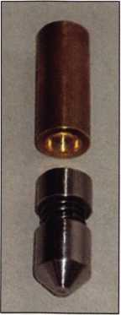

The Dolev patent provides a solu­tion to the bump key by interlock­ing a special lower and top pin upon the introduction of shock to the base of the tumbler.

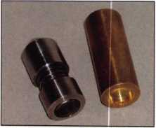

**28**

Keynotes • January 2005

FEEUNG HtEDR BY YOUR MESSAGE BOARD NAME?

TIRED OF NAMES FORCCD ON YOU LIKE, “JERRH247B"?

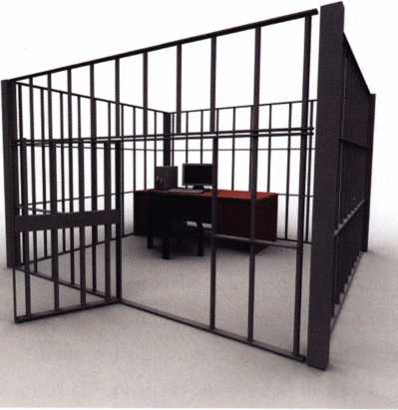

AIOA is your key to freedom.

That's right, pick any handle you want. Make  
it your own. Imagine the possibilities...

* lockdocta -
* thebestlockman -
* locksRmyLife -
* lockAbyeBaby -

Make everyone else wish they had thought of  
your idea earlier...

[www.aloa.org/membersonly](http://www.aloa.org/membersonly)

**THE HINGE DOCTOR**

**by GKL Products**

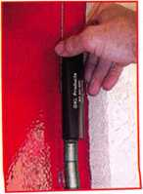

**HA1 For  
Standard**

**Commercial**

**4-1/2" x 4-1/2"**

**Butt Hinges**

**HA2**

*"The HULK"*

**For Residential Hinges**

**COMING IN  
SEPTEMBER**

**HA3**

**For Ball- Bearing**

**Commercial Hinges**

**The Hinge Doctor is a great way to repair those sagging metal**

**doors. Slip the tool over the hinge and open the door an inch**

**or two past the point where the tool binds against the**

**hinge, remove the tool and check the door,  
which should now be working properly.**

**If you're a locksmith these tools  
will turn a profit the 1st time you  
use them!**Uses **- schools, hospitals,**

**commercial buildings, storefronts**

**with butt hinges, office doors, new**

**construction, door alignment, sagging**

**doors, jail cells, anywhere there are  
commercial grade hinges.**

**HA4**

**For Prison**

**& Institutional**

**Hinges &**

**Spring Hinges**

US Patent #6450003

**[www.liingedoctor.com](http://www.liingedoctor.com)**

800-924-5397

Over

**10,000**

Satisfied

Customers

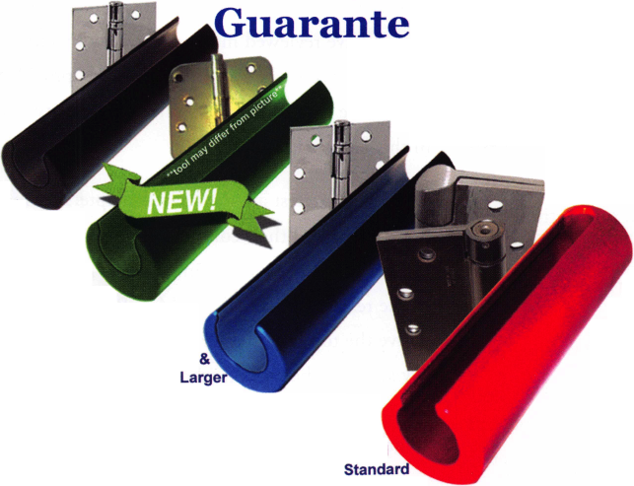

LSS+ Product Review

by Harry Sher, CML, CPS

I purchased LSS+ at the 2002 ALOA Convention. My expectation was to use the material primarily as a reference. I have found it to be not only the best reference that I have seen in this industry, but also find it extremely invaluable in other areas. These days I primarily teach and the course that I am asked to teach most often is Defense Against Methods of Entry (DAME). The major learning objective is to be able to identify the weak points in any locking device (including unfamiliar locks) and to determine the most likely and best methods of attack, to make entry in a professional manor, and to determine how to best defend against these methods of entry. With such a comprehen­sive learning objective I cannot always anticipate student interest in specific locks, tools, methods etc. LSS+ allows me to find illustrations, pictures; video and audio clips immediately in response to student questions in class and through the use of an LCD projector cover this unforeseen material straight away. The ability to find material quickly is due to a sophisticated search engine that allows you to go directly to any subject. I often refer students to various chapters and books in LSS+ for further study when they express a need to advance their skills. LSS+ can be used to learn many basic and advanced locksmithing skills such as picking, impressioning, manipulation, etc. I do not hesi­tate to recommend this material to students pursuing the ALOA Proficiency Registration Program due to the Author s meticulous adherence to the ALOA Glossary. I am grateful to Marc Tobias (LSS+ author) not only for providing this fine reference to the industry but also for serving as an assistant instructor for the DAME class at the last three ALOA conventions. He and many others such as Ken Persson the owner and inventor of Peterson tools and Gale Johnson the editor of Locksmith Ledger volunteer

their time so that on the second day of the class the stu­dents get their hands on instruction from the actual authors, inventers and manufacturers of tools discussed and demonstrated on the first day of the class.

LSS+, the multimedia version of Locks, Safes, and Security is based on the 1400 page hardbound treatise. I have a copy of the 2nd edition of the hardbound text which was published in 2001. There has always been a problem with the length of time that it takes to publish a completely revised text. Things change in our industry, often overnight. A case in point is the masterkeying controversy arising from a NY Times article last year. One of the major advantages (not to mention video and audio clips, etc.) of the multimedia version over the hardbound version is the speed that it can be updated and in our hands.

The latest release of LSS is now available in six volumes for the Locksmith edition and fourteen volumes for Government. LSS+ version 5.0 contains a great deal of new material in the form of text, graphics, audio and video files. I have reviewed much of the new material and think that Marc Weber Tobias, the author, has provided extreme­ly valuable data to the locksmith and security community in this latest release.

Of special interest are the revised chapters on master key­ing systems and their compromise. Tobias was one of those quoted in the New York Times article last year with regard to the release by AT&T and Matt Blaze of the method to derive the top level master key for a conventional master key system. The author, who is both an attorney and secu­rity expert, believes, as do many in the industry, that the ability to compromise the TMK can pose an extremely sig­

**30**

Keynotes • January 2005

nificant threat to security and create serious liability issues. “Manufacturers have spent millions of dollars to develop locks that are difficult to pick or decode. But they have done little to deal with master key security,” says Tobias.

He asks “why pick a lock, with all of the difficulties that may be involved, especially in high security applications, when you can make a key to open all of them, and with little fear of detection?” I agree.

In my view, Tobias has provided the most comprehensive examination of both the theory of master keying and how it relates to the tactical aspects of compromising these systems that has ever been written. Coining the phrase “extrapolation”, he takes the reader on a logical, step by step approach to the issue, from many different perspectives.

He details, with extremely well prepared and easy to understand graphics, tables, charts, and photographs, how master keying is accomplished, and integrates the theory into a detailed discussion of the tactical aspects of compro­mising such systems. For those of you that really do not understand this process, reading of this material and view­ing of the accompanying videos is a must. The problem can be quite complicated, as is pointed out by the author. Tobias goes into extreme detail with regard to all aspects of the extrapolation process, including the use of secondary locking systems, such as sidebars, to protect the integrity of the master key system. Unfortunately, as Tobias points out, most locks were designed to be resistant to picking and decoding, but not to the extrapolation of the TMK.

Sidebar locks, even those with a UL 437 rating, may not offer any added security to prevent the practice.

Master key systems can be protected to some degree against extrapolation, but the implementation of locks with the capabilities of multiple sidebar codes under one top level master key, must be done properly.

But Tobias was not content to just examine how master key systems could be compromised. He did an extensive analy­sis of the locking systems that provide increased security against the practice of extrapolation. In this context, Tobias provides a very detailed review of the Medeco Biaxial and M3, and the Assa 7000 VI0 to show how a master key sys­tem can be made much more secure, through the use of multiple sidebar codes. Yes Virginia, you can have two Medeco Biaxial locks in the same master key system each with a different angle in the same space and yet operated by the same TMK. If you thought you understood how the Medeco Biaxial worked in the master key environment, I can assure you that after reading this material, you will have an entirely different perspective and appreciation of the capabilities and limitations of this system.

I think few locksmiths really grasp the concept that Medeco and Assa have adopted. As a result of his detailed analysis, Tobias was then able to determine how to defeat the security that such enhancements can offer. Reading this material is a real eye-opener.

No discussion about the compromise of master key systems would be complete without an analysis of the machine that defeats restricted keyway protection, so important in the high security environment and touted by manufacturers. So, Tobias also presents an extensive examination of the Easy entrie profile milling machine and the PC software package that allows this system to reproduce restricted key-

Keynotes • January 2005

**31**

ways. There are several demonstrations of the capabilities of the Easy entrie, including the replication of the Schlage Everest profile and use of the accompanying pick set pro­duced by Peterson Manufacturing. The Everest blank, with its undercut, is one of the most challenging to reproduce, and clearly demonstrates the capabilities of this machine. The author used this lock to show how the Easy entrie can actually draw different profiles from a photograph, and then reproduce them. It offers an excellent insight into this system, and why every government agency should have one in their arsenal of tools for covert entry. The PC software version is only available to government agencies, but the locksmith must be aware of this machine and its capabili­ties when advising their customers about the security of a specific system.

Aside from the chapters on master keying, there are exten­sive additions to LSS+ from the original version, including picking of high security lever locks, alarm system bypass, analysis of different sidebar locks, discussion of biometric systems, use of system keys to test cylinders, new methods of forced entry, and many many other topics. The author has included many hours of new video and audio, as well as hundreds of graphics and photographs. A posting of all new additions can be found on the authors website, [www.security.org](http://www.security.org).

The author insures the accuracy of the technical informa­tion and defeat methods by verification with the technical experts and engineers (including manufacturers) in our industry around the world. A case in point is system key theory mentioned in the last paragraph. Marc traveled to California to interview Brian Chan, CRL at UC Berkley. Brian for my money is one of the top master key experts in the world and developed system key theory. The hundreds of video and audio clips found through out LSS+ are of experts around the world such as Brian.

If you already own the earlier release of LSS+, you will receive an automatic upgrade. If not, in my view, it is well worth its price. Of all the material incorporated into the latest edition, I believe that the most important addition is the authors material on master keying, as I described earli­er. In my view, any locksmith or security professional who is charged with the responsibility of assessing the security of a facility that utilizes any form of master keying system must read and understand this material.

It will take you several weeks to digest all of the new addi­tions to LSS+ version 5.0. I can assure you that it will be well worth your effort. Marc tells me that he is already working on Version 6.0. What next?

LSS+ is available through the ALOA Store by calling 800-532-2562 x23 or go online to [www.aloa.org/store/](http://www.aloa.org/store/) MarcTobias can be contacted by email at mwtobias@security. org.

**32**

Keynotes • January 2005

LOCKS**,** SAFES and SECURITY Electronic Infobase now available at the ***ALOA Store*** at an ALOA member discount

LSS+ is the ELECTRONIC INFOBASE edition of Locks, Safes, and Security. Locks, Safes, and Security is a treatise on the history, technology and bypass of locks and safes. It provides extremely detailed information for locksmiths and law enforcement professionals. It is comprised of FIVE volumes (LOCKSMITH VERSION) that contain as many as 4000 new images, enhanced graphics, and approximately forty hours of audio and video.

Extensive materials on forensic investigations, forced entry, and bypass of high security locks have been included. There are four books contained within the INFOBASE, including two treatises on locks and safes that were written at the height of the industrial revolution in England.

LSS+ utilizes a sophisticated search engine to instantly access the information contained within the INFOBASE. There are three security levels: PUBLIC, LOCKSMITH, and GOVERNMENT. Many chapters of the book have been expanded with text, graphics, and multimedia.

A preview copy of LSS+ is available to ALOA locksmiths. If you wish to order a preview copy, please call 800-532-2562 x23 or e- mail [orders@aloa.ora](mailto:orders@aloa.ora) and provide your ALOA member number. Once installed, you may view the contents for three days, without limitation. The default security level is Two, which provides access to materials restricted to locksmiths. This disk actually contains information for all security levels, but has been restricted to allow Level One and Two access only. No registration is required to preview the contents. This disk will only run on one computer after installation, without uninstalling all files. If you decide to buy the LSS+ Locksmith level collection, the other disks will be sent to you, together with a case for the preview disk. You must receive the full set prior to registration. ALOA will issue a product serial number to you prior to shipment..

After you purchase LSS+, you must pre-register at securitv.org and provide the product serial number and invoice number to prove authenticity. You can then register your copy by e-mail or by phone.

You may share your preview copy of LSS+ with others that may be interested.

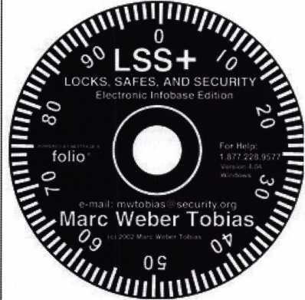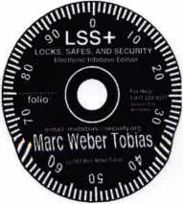

LOCKS, SAFES and SECURITY on CDRom  
now available at the ***ALOA Store*at an ALOA member** discount

Editorial

Tubular Locks and the Kensington/Kryptonite Fiascos

by Marc Weber Tobias

In August, our office issued two alerts on [www.security.org](http://www.security.org) regarding the insecurity of the tubular locks utilized by Kensington and other computer cable lock manufacturers. As a result, we received over 100,000 hits in the following days from corporations, governments, schools and private individuals throughout the world, wondering why their locks could be easily and quickly bypassed with a ball point pen. The technical answer was easy: the locks could be impressioned with the soft plastic material that is used in many pens. It just happened that the diameter of the pen barrel was precisely the same as the keyway for most standard axial pin tumbler locks. The more relevant answer was that the manufacturers either did not know of the bypass technique, or did not care. Either way, a public rela­tions nightmare followed, as well as significant costs to repair the damage and replace the locks.

As the lock makers soon learned, millions of consumers were not only affected but they were definitely not happy to have paid up to $50.00 for a computer lock and $100 for a bike lock that could be opened in seconds by just about anyone with a pen. As a result, manufacturers have been scrambling to restore public confidence in these locks and their products. Other sectors have also been affected, such as gun cabinet and motorcycle manufacturers.

The problem is not in the basic design of the tubular lock. As we all know, they have been around for more than fifty years and can be made quite secure. The real problem is in the use of cheap, low tolerance locks with poor designs that are selected solely because they can be produced very inexpensively, often for about a dollar. In addition, many companies hire engineers that are quite good a making things work, but do not have a clue about how to break things. Simply stated, a secure lock cannot be designed unless those responsible first understand methods of com­promise.

The public has no idea what is secure and what is not. They make their decision based upon price and the reputa­tion of the manufacturer. Locksmiths can play a vital role in advising their customers of potential security flaws in consumer products. In my view, they should take a proac­tive role in this process and make certain that their cus­tomers are educated, so that they can make an intelligent decision as to what level of security is really provided by a given product.

In December we released a detailed report regarding gun trigger locks. This is another example of the poor design of a lock that is widely used to protect access to weapons, especially by minors. These locks, which sell for about ten

**34**

Keynotes • January 20Q5

dollars, are designed to prevent access to the trigger and thus theoretically prevent the weapon from being fired. As we demonstrated, an eleven year old kid from Toronto was able to remove three popular gun locks in seconds from a rifle. A number of manufacturers copied each others design, and all can be shown to be easily bypassed. The difference between this design flaw and that of the com­puter and bike locks is that this one can potentially result in the injury or death of a kid.

The lesson to be learned: locksmiths and security profes­sionals should pay close attention to consumer locking devices for defects and security vulnerabilities, especially ones that they sell in their shops or recommend as secure. After all, in most cases, locksmiths are considered as the first line expert to advise their consumers as to what is safe and what is not. And, it is just good business. I believe that every security professional has an affirmative duty to disclose defects in designs that can ultimately result in the compromise of locks and locking systems. Although some locksmiths may disagree with this philosophy, they must understand that there are no secrets. Security by Obscurity

does not work. If there is a defect, it will be exploited. Whether it is a vulnerability in master key systems, or the ability to open a gun trigger lock, the public needs to know before they have a problem so they can take appro­priate steps to protect themselves. It is simply naive to believe that if we don t talk about a problem, it will not exist or not cause difficulty. Even at the risk of educating the “bad guys” they will find out anyway. So, we might as well be up front with everyone.

Locks protect people and property from various hazards. The manufacturers would be well advised to remember that they are not only in the business to make a profit, but to produce products that do what they represent: provide security. Proper testing should be done before a product is released to insure that adults, much less kids, cannot use common implements and techniques, such as ball point pens, knives, and ice picks to defeat locks that are sup­posed to provide security.

Keynotes • January 2005

**3**

Classifieds



EMPLOYMENT

RELOCATE TO "THE LAST FRONTIER"

Action Security, Inc. is a 41-year-old security company that is interested in hiring you. Its services include electron­ic security: bank/credit union security; wholesale products; hollow metal fabri­cation; contract hardware; retail securi­ty centers; and professional locksmith services. We have three retail loca­tions andoffer statewide service. Opportunity and professional growth is encouraged. Ideal candidate must be neat in appearance, people orient­ed, self motivated ahard working. Applicants must possess a good driv­ing record and pass drug testing.We will train the right candidate.

Action offers full benefits package; competitive wages, medical insurance, paid vacation & sick days, continuous education, and profit sharing. Please send resume or email [info@actionsecuri- ty.com](mailto:info@actionsecuri-ty.com) if interested in relocating to Alaska.

EXPERIENCED LOCKSMITH

Established & expanding company in center New Jersey is seeking experi­enced help in residential/commer- cial/auto/access control/safe work. Top pay for top mechanics along with medical, dental, paid vacation, no night calls. Apple Locksmith, 4030 Route 9 South, Morganville, NJ 07751, 732-970-1500 or fax resume to 732-970-9725 - Attention:

Andy or Jack.

PROFESSIONAL EXPERIENCED LOCKSMITH(S) WANTED

We are in need of experienced and motivated locksmiths to help in any or all of the following: residential, com­mercial, auto, access control. CCTV experience a plus. Our shop is located in North Atlanta, GA and services the entire metro Atlanta area both inside and outside of the perimeter. Must have a clean criminal and driving record, professional attitude, and be able to work with little or no supervi­sion. Must supply references and back­ground check. Competitive pay based on experience. Flexible hours.

Interested Parties should call (404) 788-6079 or fax your resume to (770) 246-0448 or email resume to [lock- job@hotmail.com](mailto:lock-job@hotmail.com).

NOTICES

2005

EAST COAST REGIONAL LOCK & SECURITY SHOW (CLASSES, TRADE SHOW,

AND BANQUET)

March 3rd thru March 6th Crowne Plaza Meadowlands Hotel 2 Harmon Plaza Secacus, NJ

For More Information:

PO Box 2441

Morristown, NJ 07962-2441 Fax 973-538-1588 Or visit our web site at [www.mlanj.org](http://www.mlanj.org)

THE OKLAHOMA MASTER LOCKSMITHS ASSOCIATION'S ANNUAL DISTRIBUTORS SHOW

February 5, 2005, 9a.m. - 5p.m. at the Holiday Inn Select, Tulsa, Oklahoma. Sponsored by IDN and Acme. Please call Mike McGrew at 918-333-9136 for more information.

WANTED TO BUY/SELL

WELL ESTABLISHED

Key and Lock business. Good return on investment. $275,000. Call Mark Gillispie at 503-812-2615.

BUSINESS FOR SALE

Only locksmith in the county, five years of growing sales. Van, tools, codes machines, and inventory. Reasonably priced. ALOA member. Located in NW Ohio. Call 419-232- 4404 or email [locksmith45891@yahoo.com](mailto:locksmith45891@yahoo.com)

GREAT OPPORTUNITY TO OWN

Busy store established in 1977, three trucks on the go all day. Great cli­mate to work in, 40 miles north of San Diego. Owner retiring. Business needs energetic, experienced person for good customers. Call 760-801- 9351 for info regarding sales and asking price.

WHOLESALE SAFE DEPOSIT LOCKS

Diebold, Herring Hall Marvin, llco, LeFebure, Mosler, Precision, S&G, Security Corp, Yale. Now available Safe Deposit Boxes Sections, Doors, Hinges and Bond Tins. Vault Doors, Safes, Night Depositories, Vault Lockers and One Inch Plate Steel are also stocked items. Call WBI (954)484-2404 or [Sales@WBI.US](mailto:Sales@WBI.US).

EQUIPMENT FOR SALE

Scotsman #747X11 Tubular Key Machine (cuts to codes or duplicates) with manual, used very few times - $500.00 HPC general code book 1A - $50.00 - A set Reed code books 1-14 with index $500 for set - Reed code book #5 Padlocks $50.00 - Baxter code books 1, 5,

11, 19, 20, 22, 23, 24, 27, 28,

29, 30, 31, 34, 35, 36, 37, 38 updated through 2003 $500.00 for set - Kent-moore Vats key interpreter $100.00 - A-l Auto key punch set with case (PAKSSB) $500.00 - ASP Auto Cap Assortment #A0-002 (with the original face caps) $100.00 - An

inventory of Dead Bolts, lock sets etc. Listing will be sent if you will send a SASE (business size). All items are F.O.B. Narvon, PA. Byron A. Rohrbach RL, 2543 School House Lane, Narvon, PA, 17555-9004. Phone (717) 445-1240.

FOR SALE

Key Blanks: Original Yale, Hurd, replacement Independent, Graham, Keil, misc. mfg. For a list or to speci­fy your needs email or write: [c- cameron@triad.rr.com](mailto:c-cameron@triad.rr.com), Charles Cameron, CML, 2818 Sherwood St., Greensboro, NC 27403.

FOR SALE

Al-Pak-A-Punch III never used in carry­ing case, with 7 auto kits (Ford FA/FB/Ford 10Cut/GM6 Cut/Chrysler F/M/Y 60000/ Chrysler EP/ES/Chrysler S/L all never used! $400.00 for all. Both in carrying cases. 860-423-5604.

Classified Advertising Policy

Classified advertising space is provided free of charge to ALOA members and for a fee of $2.00 per word, $40.00 minimum for non members. Classified ads may be used to advertise used merchandise and over­stocked items for sale, "wanted to buy" items, business opportunities, employment opportunities/positions wanted and the like. Members or non members wishing to advertise services or new merchandise for sale may purchase a "Commercial Classified Ad" for a fee of $4.00 per word with a minimum of $100.00. Each ad will run for two issues. For blind boxes there is a $10.00 charge for members and non members.

All ads must be submitted in writing to the Advertising Sales Department via fax at 817-645-7599 or through an email to [adsales@aloa.org](mailto:adsales@aloa.org) by the fifteenth of the month two months prior to issue date. ALOA reserves the right to refuse any classified advertisement that it deems inappropriate according to the stated

purpose of the classified advertising section.



Distributor

**1st In Hardware, Inc.**

Phone: 866-397-9900  
Fax: 866-646-0045  
www. 1 stinhardware.com

**ADI Inc.**

Phone: 631-692-1000  
Fax: 631-692-3011

**Accredited Lock Supply Co.**

Phone: 800-652-2835  
Fax: 201-865-0030  
[www.acclock.com](http://www.acclock.com)

**Ace Lock & Security Supply**

Phone: 800-223-5625  
Fax: 908-688-2442  
[www.acelock.com](http://www.acelock.com)

**Andrews Wholesale Lock Supply**

Phone: 717-272-7422  
Fax: 717-274-8659  
[www.andrewslock.com](http://www.andrewslock.com)

**Boyle & Chase Inc.**

Phone: 800-325-2530  
Fax: 800-205-3500  
[www.boyleandchase.com](http://www.boyleandchase.com)

**Chinrose International**

Phone: 503-357-7553  
Fax: 503-357-5522  
[www.chinrose.com](http://www.chinrose.com)

**Clark Security Products**

Phone: 888-784-1311  
Fax: 619-718-7333  
[www.clarksecurity.com](http://www.clarksecurity.com)

**Cook's Building Specialties**

Phone: 505-883-5701  
Fax: 505-883-5704

**Dire's Lock & Key Company**

Phone: 303-294-0176 Fax: 303-294-0198

**Direct Security Supply, Inc.**

Phone: 800-252-5757 Fax: 800-452-8600

**Discount Key Machines.Com/Busch**

Phone: 800-332-8724 Fax: 407-363-4666

**Doyle Security Products**

Phone: 800-333-6953 Fax: 612-521-0166 [www.doylesecurity.com](http://www.doylesecurity.com)

**Dugmore and Duncan, Inc.**

Phone: 888-384-6673 Fax: 888-329-3846

|  |  |  |  |
| --- | --- | --- | --- |
| if * ri <  u ' | > s o c | •  i | a t e |
| **t**1 | m e m b | CD | r s |
| **E. L. Reinhardt Co., Inc.** | **M. Zion Company** |  | **Turn 10 Wholesale** |
| Phone: 800-328-1311 | Phone: 212-349-8677 |  | Phone: 800-848-9790 |
| Fax: 651-481-0166 | Fax: 212-964-0495 |  | Fax: 800-391-4553 |
| [www.elreinhardt.com](http://www.elreinhardt.com) | [www.mzion.com](http://www.mzion.com) |  | **U.S. Lock Corp.** |
| **Ewert Wholesale Hardware** | **McDonald Dash Locksmith Supply** | | Phone: 800-925-5000 |
| Phone: 800-451-0200 | Phone: 800-238-7541 |  | Fax: 800-338-5625 |
| Fax: 708-597-0881 | Fax: 901-366-0005 |  | [www.uslock.com](http://www.uslock.com) |
| **Fairway Supply, Inc.** | [www.mcdonalddash.com](http://www.mcdonalddash.com) |  | **Wilson Safe Company** |
| Phone: 214-350-0021 | **Monaco Lock Co.** |  | Phone: 215-492-7100 |
| Fax: 214-352-4299 | Phone: 800-526-6094 |  | Fax: 215-492-7104 |
| www. fa i r ways upply.com | Fax: 800-845-5625 |  | [www.wilsonsafe.com](http://www.wilsonsafe.com) |
| **Foley-Belsaw Company** | [www.monacolock.com](http://www.monacolock.com) |  |  |
| Phone: 800-821-3452  Fax: 816-483-5010 | **Omaha Wholesale Hardware**  Phone: 800-238-4566 | | **Manufacturer** |
| [www.foley-belsaw.com](http://www.foley-belsaw.com) | Fax: 402-444-1664 [www.omahawh.com](http://www.omahawh.com) |  | **A & B Safe Corporation** |
| **Fried Brothers Inc.** |  | Phone: 800-253-1267 |
| Phone: 800-523-2924 | **RA-Lock Company** |  | Fax: 856-863-1208 |
| r Fax: 215-592-1255  [www.fbisecurity.com](http://www.fbisecurity.com) | Phone: 972-775-6301  Fax: 972-775-6316 |  | [www.a-bsafecorp.com](http://www.a-bsafecorp.com) |
| [www.ralock.com](http://www.ralock.com) |  | **ABUS Lock Company**  Phone: 800-352-2287  Fax: 602-516-9934 [www.abus.com](http://www.abus.com) |
| **Hans Johnsen Company**  Phone: 214-879-1550  Fax: 214-879-1530  **Hardware Agencies, Ltd.** |
| **Security Distributors Inc**  Phone: 800-333-6953  Fax: 612-524-0166 |
|  | **Access Security Products Ltd.** |
| Phone: 416-462-1921 | **Security House** |  | Phone: 905-337-7874 |
| [www.hardwareagencies.com](http://www.hardwareagencies.com) | Phone: 905-669-5300 |  | Fax: 905-337-7873 |
| **IDN Incorporated**  Phone: 817-421-5470 | Fax: 905-660-6313 [www.securityhouselock.com](http://www.securityhouselock.com) |  | [www.access-safe.com](http://www.access-safe.com)  **Adams Rite Mfg Company** |
| Fax: 817-421-5468 | **Security Lock Distributors** |  | Phone: 800-872-3267 |
| [www.idn-inc.com](http://www.idn-inc.com) | Phone: 800-847-5625 |  | Fax: 800-232-7329 |
| **Intermountain Lock & Supply**  Phone: 800-453-5386 | Fax: 800-878-6400 [www.securitylockdistributors.com](http://www.securitylockdistributors.com) |  | [www.adamsrite.com](http://www.adamsrite.com)  **Adesco Safe Mfg. Company** |
| Fax: 801-485-7205 | **Shin-An Enterprise Inc.** |  | Phone: 800-694-9340 |
| [www.intermountainlock.com](http://www.intermountainlock.com) | Phone: 718-225-5380 |  | Fax: 562-408-6427 |
| **International Electronics, Inc** | Fax: 718-819-0723 |  | [www.adesco.com](http://www.adesco.com) |

Phone: 800-343-9502 Fax: 617-821-4443

**Jo Van Distributors**

Phone: 416-752-7249 Fax: 416-752-7282 [www.jovanlock.com](http://www.jovanlock.com)

**Lockmasters, Inc.**

Phone: 859-885-6041 Fax: 859-885-7093 [www.lockmasters.com](http://www.lockmasters.com)

**Locks Company**

Phone: 800-288-0801 Fax: 305-949-3619

**Locksmith Ledger International**

Phone: 770-886-0800 Fax: 770-889-7703 [www.lledger.com](http://www.lledger.com)

**Southern Lock and Supply Co.**

Phone: 727-541-5536 Fax: 727-544-8278 [www.southernlock.com](http://www.southernlock.com)

**Stone & Berg Wholesale**

Phone: 800-225-7405 Fax: 800-535-5625

**The Locksmith Store Inc.**

Phone: 847-364-51 1 1 Fax: 847-364-5125 [www.locksmithstore.com](http://www.locksmithstore.com)

**Timemaster Inc.**

Phone: 859-259-1 878 Fax: 859-255-0298 [www.time-master.com](http://www.time-master.com)

**Top Notch Distributors, Inc.**

Phone: 800-233-4210 Fax: 800-854-4146 [www.topnotch.bz](http://www.topnotch.bz)

**Adrian Steel Company**

Phone: 800-677-2726 Fax: 517-265-5834 [www.adriansteel.com](http://www.adriansteel.com)

**All Five Tool Company, Inc.**

Phone: 860-583-1691 Fax: 860-583-4516 [www.all5tool.com](http://www.all5tool.com)

**American Lock Company**

Phone: 708-534-2000 Fax: 708-534-0531 [www.armericanlock.com](http://www.armericanlock.com)

**American Security Products**

Phone: 909-685-9680X1083 Fax: 909-685-9685 [www.amsecusa.com](http://www.amsecusa.com)

**Best Metaline Inc.**

Phone: 714-441-0098 Fax: 714-441-0977

Keynotes • January 2005

associate

members

**Bianchi USA, Inc.**

Phone: 800-891-2118 Fax: 216-803-0202

**Buddy Products**

Phone: 800-886-8688 Fax: 312-733-8356 [www.buddyproducts.com](http://www.buddyproducts.com)

**CCL Security Products**

Phone: 800-733-8588 Fax: 847-537-1800

**COMPX Security Products**

Phone: 864-297-6655 Fax: 864-297-9987 [www.compxnet.com](http://www.compxnet.com)

**D&D Technologies (USA), Inc.**

Phone: 714-677-1300X292 Fax: 714-677-1299 [www.ddtechusa.com](http://www.ddtechusa.com)

**DETEX Corp.**

Phone: 800-729-3839 Fax: 830-620-6711 [www.detex.com](http://www.detex.com)

**DORMA Architectural Hardware**

Phone: 717-336-3881 Fax: 717-336-2106 [www.dorma-usa.com](http://www.dorma-usa.com)

**Datakey Electronics**

Phone: 952-746-4066 Fax: 866-289-4212 [www.datakeyelectronics.com](http://www.datakeyelectronics.com)

**Don-Jo Manufacturing, Inc.**

Phone: 978-422-3213 Fax: 978-422-3467 [www.don-jo.com](http://www.don-jo.com)

**Door Controls International**

Phone: 800-742-3634 Fax: 800-742-0410 [www.doorcontrols.com](http://www.doorcontrols.com)

**ESP Lock Products Inc.**

Phone: 800-434-8960 Fax: 978-562-9859

**FireKing Security Products**

Phone: 800-457-2424 Fax: 800-896-6606 [www.fkisecuritygroup.com](http://www.fkisecuritygroup.com)

**Framon Manufacturing Company Inc.**

Phone: 989-354-5623 Fax: 989-354-4238 [www.framon.com](http://www.framon.com)

**HPC, Inc.**

Phone: 847-671-6280 Fax: 847-671-6343 [www.hpcworld.com](http://www.hpcworld.com)

**HY-KO Products Co.**

Phone: 330-467-7446 Fax: 330-467-7442

**Hammerhead Industries, Inc.**

Phone: 805-658-9922 Fax: 805-658-8833 [www.gearkeeper.com](http://www.gearkeeper.com)

**Ingersoll Rand SSA**

Phone: 317-613-8025 Fax: 317-613-8068 [www.schlagelock.com](http://www.schlagelock.com)

**Jet Hardware Mfg., Co.**

Phone: 718-257-9600 Fax: 718-257-0973 [www.jetkeys.com](http://www.jetkeys.com)

**KABA ILCO Corp.**

Phone: 252-446-3321 Fax: 252-446-4702 [www.kaba-ilco.com](http://www.kaba-ilco.com)

**KEY-BAK/West Coast Chain Mfg.**

Phone: 909-923-7800 Fax: 909-923-0024 [www.keybak.com](http://www.keybak.com)

**Keri Systems Inc.**

Phone: 408-451-2520 Fax: 408-441-0309 [www.kerisys.com](http://www.kerisys.com)

**Knaack Manufacturing Co.**

Phone: 800-456-7865 Fax: 815-459-9097 [www.weatherguard.com](http://www.weatherguard.com)

**LAB Security**

Phone: 800-243-8242 Fax: 860-583-7838 [www.labpins.com](http://www.labpins.com)

**La Gard Inc.**

Phone: 310-325-5670 Fax: 310-325-5615 [www.lagard.com](http://www.lagard.com)

**Lock America, Inc. dba L.A.I. Group**

Phone: 714-373-2993 Fax: 714-373-2998

[www.laigroup.com](http://www.laigroup.com)

**Lucky Line Products, Inc.**

Phone: 858-549-6699 Fax: 858-549-3241 [www.luckyline.com](http://www.luckyline.com)

**M.A.G. Security**

Phone: 714-891-5100 Fax: 714-892-6845 [www.magsecurity.com](http://www.magsecurity.com)

**MUL-T-LOCK USA, Inc.**

Phone: 800-562-3511 Fax: 973-778-4007 [www.mul-t-lock.com](http://www.mul-t-lock.com)

**Medeco Security Locks**

Phone: 540-380-5000 Fax: 540-380-5010 [www.medeco.com](http://www.medeco.com)

**ROFU International Corp.**

Phone: 253-922-1828 Fax: 253-922-1728 [www.rofu.com](http://www.rofu.com)

**Rutherford Controls Int'l Co.**

Phone: 757-427-1230 Fax: 757-427-9549 [www.rutherfordcontrols.com](http://www.rutherfordcontrols.com)

**STRATTEC Security Corp.**

Phone: 414-247-3415 Fax: 414-247-3692 [www.strattec.com](http://www.strattec.com)

**Sargent & Greenleaf, Inc.**

Phone: 800-826-7652X201 Fax: 859-885-3063 [www.sargentandgreenleaf.com](http://www.sargentandgreenleaf.com)

**Sargent Manufacturing Co.**

Phone: 800-727-5477 Fax: 888-863-5054 [www.sargentlock.com](http://www.sargentlock.com)

**Schwab Corp.**

Phone: 765-447-9470 Fax: 765-447-8278 [www.schwabcorp.com](http://www.schwabcorp.com)

**Securitron Magnalock Corp.**

Phone: 775-355-5625 Fax: 775-355-5636 [www.securitron.com](http://www.securitron.com)

**Security Door Controls**

Phone: 805-494-0622 Fax: 805-494-8861

[www.sdcsecurity.com](http://www.sdcsecurity.com)

**Security Solutions**

Phone: 405-376-1600 Fax: 405-376-6870

[www.securitysolutions-usa.com](http://www.securitysolutions-usa.com)

**Townsteel, Inc.**

Phone: 626-858-5080 Fax: 626-858-3393 [www.townsteel.com](http://www.townsteel.com)

**Trine Access Technology**

Phone: 718-829-2332 Fax: 71 8-829-6405 [www.trineonline.com](http://www.trineonline.com)

**Victor E-lok, Inc.**

Phone: 949-916-1200 Fax: 949-916-1300 [www.victorelok.com](http://www.victorelok.com)

**Videx Inc.**

Phone: 541-758-0521 Fax: 541-752-5285 [www.videx.com](http://www.videx.com)

**YSG Door**

**Security Consultants, Inc.**

Phone: 800-438-1951 Fax: 800-338-0965

Service

Organization

**Allstate Insurance Company**

Phone: 800-859-0247 Fax: 847-326-7509 [www.allstate.com](http://www.allstate.com)

**Cross Country Automotive Services**

Phone: 800-541-2262 Fax: 781-393-0256 [www.argosi](http://www.argosi) .com

**Massglass & Door Service**

Phone: 888-742-8837 Fax: 805-497-2255 [www.massglass.com](http://www.massglass.com)

**Webster Safe & Lock Co., Inc.**

Phone: 901-332-291 1 Fax: 901-332-2878 [www.webstersinc.com](http://www.webstersinc.com)

Keynotes •

January 2005



Outlook for Association Health Plan Legislation in 2005

Looking ahead to 2005 and the start of the 109th Congress in January, the outlook for the Association Health Plan (AHP) legislation (H.R. 660/S. 545) has truly never been better, while the need has never been greater. As small and medium-sized businesses continue to struggle mightily to provide affordable health benefits to workers, ALOA's Healthcare Coalition will continue working towards the goal of providing association-sponsored health plans with a new option of operating under uniform regulation provided by the federal Employee Retirement Income Security Act. This will provide AHPs with maximum plan design flexibility and other operating efficien­cies that will enable associations to deliver higher quality and more affordable health benefits to employers and their workers.

The political landscape in the new Congress will be significantly improved with respect to the prospects for enactment of the AHP legislation. House Education and Workforce Committee Chair John Boehner (R-OH) has already indicated that the Republican Leadership plans to move the AHP bill through the House in early 2005. With Republicans adding slightly to their majority in the House in the 2004 elections, having the AHP bill approved again on a strong bipartisan vote, as it was in both 2003 and 2004, is highly likely.

As has been the case in previous years, the focus will turn to the Senate once the House approves the AHP legislation. The 2004 elections have improved the outlook for AHP legislation in the Senate substan­tially. The election of five new Senators who have supported the AHP bill during their tenure in the House provides a stronger foundation for building majority support for the bill in the Senate. These new

**40**

Senators, who replace retiring or defeated Senators who were believed to have been opposed to the AHP legislation, are: John Thune (R-SD); Jim DeMint (R-SC); Johnny Isakson (R-GA); David Vitter (R-LA); and Richard Burr (R-NC). Given their past support for the AHP bill in the House, it is likely that they will continue to be supportive in the Senate. Based on this assumption, this is an increase of five votes in favor of the AHP bill!

Another new Senator, Mel Martinez (R-FL), is a for­mer Bush Administration cabinet official who replaces outgoing Senator Bob Graham (D-FL), and this hopefully will be another vote pick-up! While Senator-elect Tom Coburn (R-OK) has raised con­cerns about the AHP bill during his tenure in the House, he indicated to several organizations during his Senate campaign that he will support the AHP bill in the Senate if elected. This will be a huge improvement over his processor, retiring Senator Don Nickles (R-OK), who has been an ardent foe of the AHP bill over the past ten years. Also, given our past success in attracting support for the AHP bill from both moderate and liberal Democrats in the House, the two new Democratic Senators, Ken Salazar (D-CO) and Barack Obama (D-IL), should be prime targets for our efforts to gain new support for the bill.

Another key development is that Senator Judd Gregg (R-NH), an opponent of the AHP bill, will no longer be Chair of the Senate Health, Education, Labor and Pensions (HELP) Committee, which has jurisdiction over the legislation, in the 109th Congress. Gregg will be moving on to Chair the Budget Committee. The new HELP Committee Chair will be Senator Mike Enzi (R-WY). While Senator Enzi has raised concerns about the AHP legislation in the past, he does have a record of support for

Keynotes • January 2005

small business issues, and therefore should be will­ing to work with supporters of the AHP legislation to address legitimate concerns while moving the bill forward. Senator Gregg never indicated any such willingness at all. This is another positive develop­ment which bodes well for the AHP bill in the Senate.

The bottom line is that the new Senate should be more favorable to the AHP legislation than at any time in the past. Senators Olympia Snowe (R-ME) and Jim Talent (R-MO) have indicated they plan to reintroduce the AHP bill and are very excited about the increased prospects for enactment. With President Bush now in a position to push the Senate to move on his health care agenda, the outlook for AHP legislation in 2005 is better than ever!

However, there are still significant hurdles to be overcome for the AHP bill to be enacted into law, and a strong grass- roots lobbying effort will be essential to achieve our goal of enactment in 2005.

When the 109th Congress convenes in January, com­mittee assignments will be one of the first orders of business, and this will give us further indication of where lobbying efforts need to be targeted. ALOA's coalition is already working with other supporting organizations to begin working with the both existing and new members of the House and Senate to build greater support for the AHP legislation. This effort will include retaining a consultant to conduct a thorough evaluation of how the AHP legislation will better enable associations to deliver high quality health benefits to employers at affordable rates, and how this will boost the expansion of affordable health benefits and ulti­mately benefit currently uninsured American workers. Such a detailed study will be an effective tool to utilize on Capitol Hill in support of our efforts to gain enactment of the AHP legislation.

Best Regards,



Paul M. Kanitra

LEGISLATIVE  
ACTION NETWORK

You’re a professional locksmith,  
not a professional lobbyist.

You can’t be on the steps of every state capitol and walking the halls of the federal government to protect your profession, but...

WE CAN!

The ALOA Legislative Action Network (LAN) needs Your support for the Voice of Our Profession.

The ALOA Legislative Action Network is constantly working to influence legislation that’s important to the locksmithing profession. We are working in your best interests to promote legislation that will have a posi­tive impact on our proud profession; while preventing or limiting legislative efforts that are harmful. To con­tinue, we need your help to ensure the success of our legislative program for 2004!

If you contribute $25-$99.99 to the Legislative Action Fund, you automatically become a member of the Legislative Action Network (LAN). The LAN is an important tool in raising the standards of our profes­sion through the legislative process by making sure that locksmiths have the final say in how our industry will be run. As a LAN member, you will receive:

* The Legislative Action Network Update alerting you to important legislation in your state and around the country.
* Networking opportunities with ALOA members who share the belief that legislative involvement is important to the effectiveness of our association.
* A listing of your state representatives and senators including capital and district addresses, and phone and fax numbers on both hard copy and disk.
* A comprehensive guide to lobbying in your state capital, so you can be the "voice of ALOA" to legis­lators.
* LAN stationary and envelopes for sending official letters to legislators, lobbying on ALOA’s behalf.
* A lapel pin designating you as a special ALOA LAN member,
* Recognition in Keynotes magazine.
* An invitation to an exclusive reception at the annu­al ALOA convention for LAN members.

When you donate $100 or more, you become part of the heart of the legislative program through LAN membership and receive the following:

* A reserved place of distinction on the special LAN Council
* Discounts on ALOA bookstore items and a 10 % rebate on all ACE classes.
* Complimentary Legislative Convention merchan­dise.
* It’s easy to do Your part.. .just join TODAY!!

NOTE: Contributions or gifts to the Associated Locksmiths of America, Inc. are not tax deductible as charitable contributions or as business expenses under IRC - 162(e).

Keynotes • January 2005

**41**

Keynotes

Buyer's Marketpla

IN-STOCK...MORE SAFES

***FREE Freight Program***

***(30 States)***

**AMSEC** FreKing **fiatftall** HAYMAN MEIUNK **y/CFOR**

**TURPI tO**

**WHOLESALE SERVICE**

800-848-9790

25+ Function

Multi-Tool

**—** Lifetime Warranty **—**

)R LOCKSMITHS ONLY

* 25 Functions
* Services Schlage, Baldwin,  
  Corbin/Russwin, Lori,  
  Adams Rite, Master  
  padlocks, Medeco, Arrow,

Jackson crossbars and

many more!

Call Toll Free—

888-634-LOCK

[www.lockmantools.com](http://www.lockmantools.com)



SAFI CORPORATION

MANUFACTURES OF QUAUTY DEPOSITORY SAFES AND CHESTS

DISTRIBUTING FROM WAREHOUSES IN

* LOS ANGLES, CA
* CHICAGO, IL
* GLASSBORO, NJ

A & B is now a stocking distributor

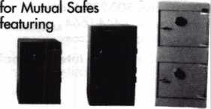

AB-4-30-3S AB-9-2 WS 10-2

Chose from over 75 models in stock

We ship your order within

24 hours

See us

at [www.a-bsafecorp.com](http://www.a-bsafecorp.com)  
*800-253-1267*

Fax 856-863-1208

CALL FOR YOUR  
CATALOG TODAY

Keynotes • January 2005

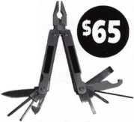

about the authors

**Marc Tobias**

Marc Weber Tobias is the author of Locks, Safes, and Security, and LSS+, the multimedia edition of the book. He is an investigative attorney in Sioux Falls, South Dakota, and has written five police textbooks He has worked for govern­ment and private industry with regard to security issues involving the bypass of high security locks and alarm systems. The material for this article was taken from LSS+.Extremely detailed information relating to the use of Bump keys can be found in LSS+ Version 5.1, available from ALOA and other vendors.Extensive video within LSS+ shows the correct procedure for opening several different kinds of locks with the bump key. The author may be contacted at [mwt5obias@security.org](mailto:mwt5obias@security.org).

**Greg Perry, CML, CPS**

Greg Perry, CML, CPS, has been in the locksmith industry for 20 years. He’s spent half of that time as a field techni­cian for Security Engineering in Ridgecrest, CA. Greg is also a past president of the Desert Counties Chapter of the California Locksmiths Association. He has also won the 2002 Keynotes Author of the Year Award. You can email him at [glmperry@iwvisp.com](mailto:glmperry@iwvisp.com).

**Harry Sher, CML, CPS**

Harry Sher is a Certified Master Locksmith and Certified Professional Safe Technician. He has been a locksmith since the 1950's. He is an active member of the Associated Locksmiths of America, The Safe and Vault Technicians Association and the International Association of Investigative Locksmiths and numerous local associations. He is cur­rently the Vice President of the Oklahoma Master Locksmith Association and Past President of the Missouri-Kansas Locksmith Association. Harry has over 37 years of Federal Service. He has taught Federal Officers beginning in 1967. Most recently, he was responsible for building a training facility for the National Nuclear Security Administration. He has taught classes for many local and regional locksmith associations as well as the Associated Locksmiths of America and the Safe and Vault Technicians Association. Although he teaches Safe and Vault classes such as GSA Containers and general locksmithing classes such as 1C Core and master keying, his favorite class is Defense Against Methods of Entry.

**Simon Liu**

Simon Liu is director of computer and communications systems at the National Library of Medicine. He is also an adjunct professor at Johns Hopkins University. Contact him at [simonJiu@nlm.nih.gov](mailto:simonJiu@nlm.nih.gov).

**Mark Silverman**

Mark Silverman is a technical advisor at the Center of Information Technology, National Institutes of Health. Contact him at [mls@nih.gov](mailto:mls@nih.gov).

**44**

Keynotes • January 2005

call me.

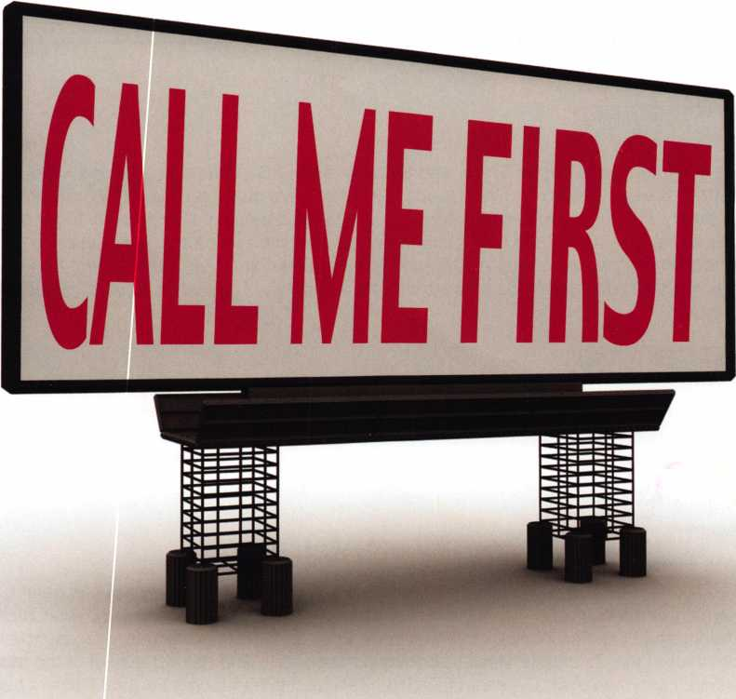

which one catches your attention?

Bigger is sometimes better. And when someone is in need of your services, you want to take every opportunity to make your name prominent in the minds of searching consumers.

Introducing a new advertising solution from ALOA. At our new public locksmith search site, findalocksmith.com, you can now purchase an ad for your business that will shine brightly on the results page whenever someone searches for a locksmith in your zip code. The initial cost is only $30.00, and each additional zip code you add is only $5 extra. Don't miss this great opportunity!

Call Kim Hammond at 817-645-6778 for details.

Spaces for each zip code are limited. Call to reserve yours now!



**New Generation STAR XL CAN Transponder Programmer**

I've lost my Taurus keys...

:an you make me a new set?'

NGS STAR XL CAN Locksmith 8008LXLC

How much of your money lave you sent to the ocal Ford Dealer?

)id you Know...

..the Dealers charge an average of $100 per ransponder key?

.you can get the factory ransponder tool for less han the cost of doing one ;ey per month?

>ay "YES” to $100 )hone calls.

Use what the Dealers use for complete  
coverage on ALL Ford/Lincoln-Mercury and  
Mazda vehicles equipped with transponder  
keys. The NGS XL CAN offers complete  
transponder coverage including CAN protocol  
and the ability to clear ALL Diagnostic Service Codes

>u re never on ^our^own >11 Free Technical Suddo

**2004 Software Update and CAN Vehicle  
Interface Module now available.**

*mac*

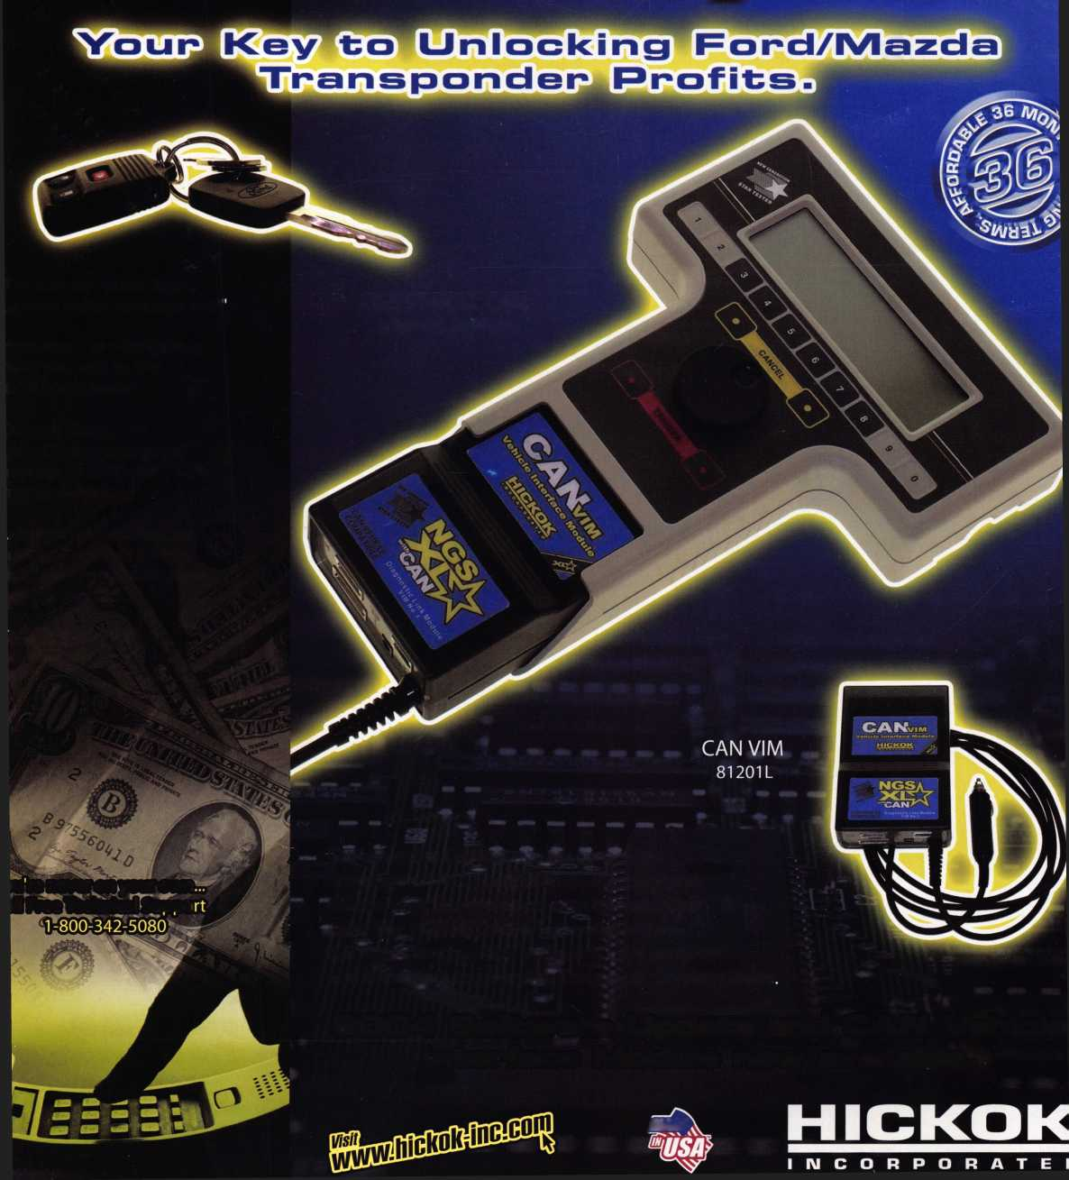

**Security Products**

**301 West Hintz Road Wheeling, IL 60090 Telephone: 800.733.8588 Fax: 847.537.1881 [www.cclsecurity.com](http://www.cclsecurity.com)**

* No Keys to Carry, Lose or Break
* Re-settable Combination
* Brass and Hardened Steel Shackles
* Ideal for Chain Link Fence and Gates
* Construction Job Sites and Gang Boxes
* Tool Cribs and Supply Areas
* Marine Use
* Oil, Gas and Pipeline Security

